1. Approved button not display while click the view icon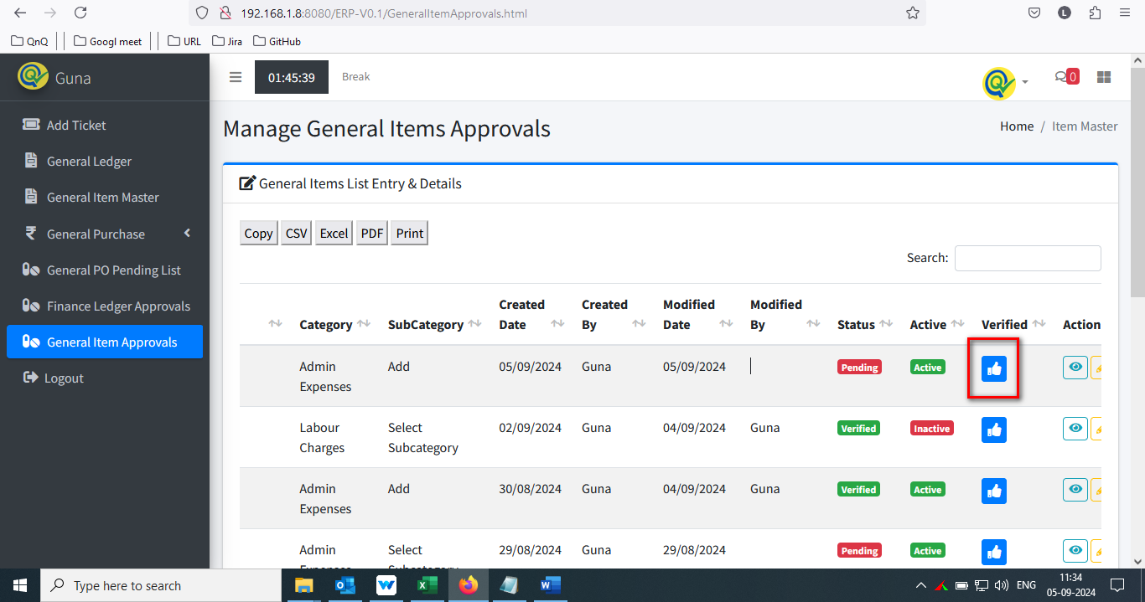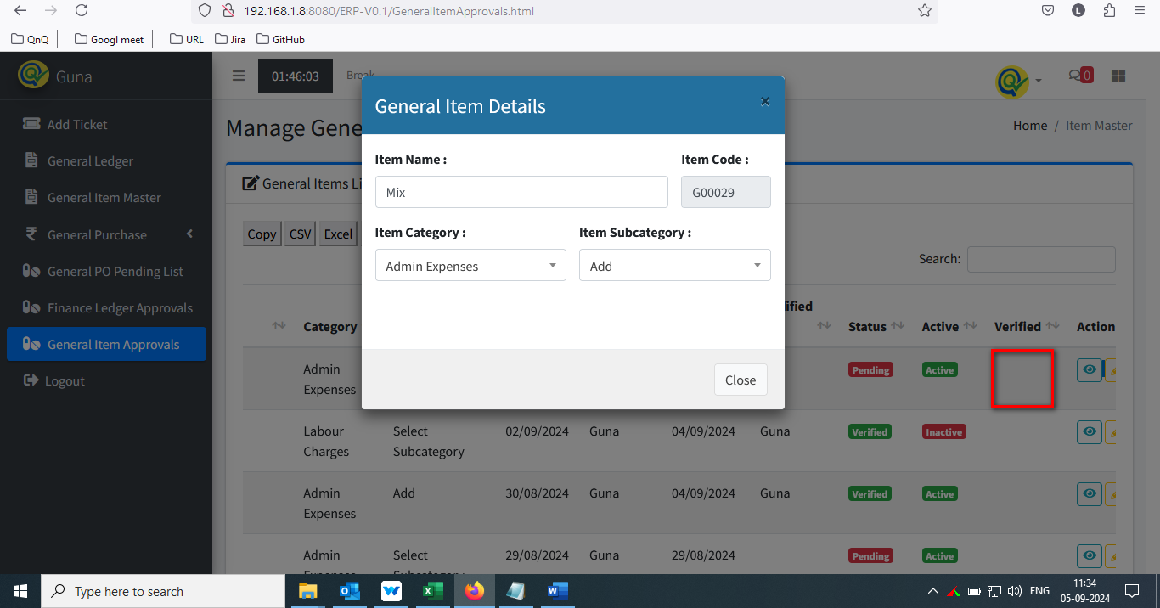

//

2. Mismatch name display for Menu and Page title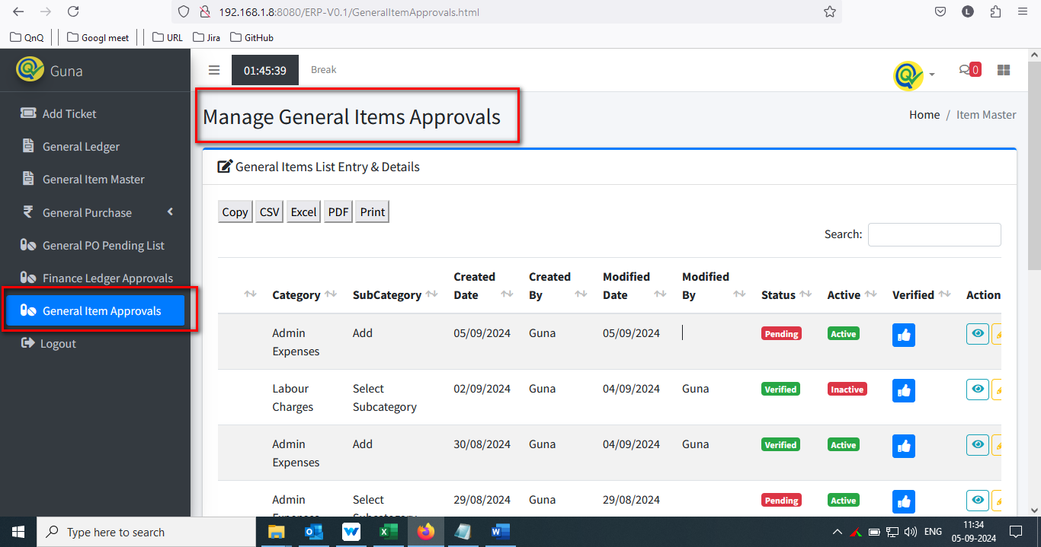

//

3. Mismatch column header name display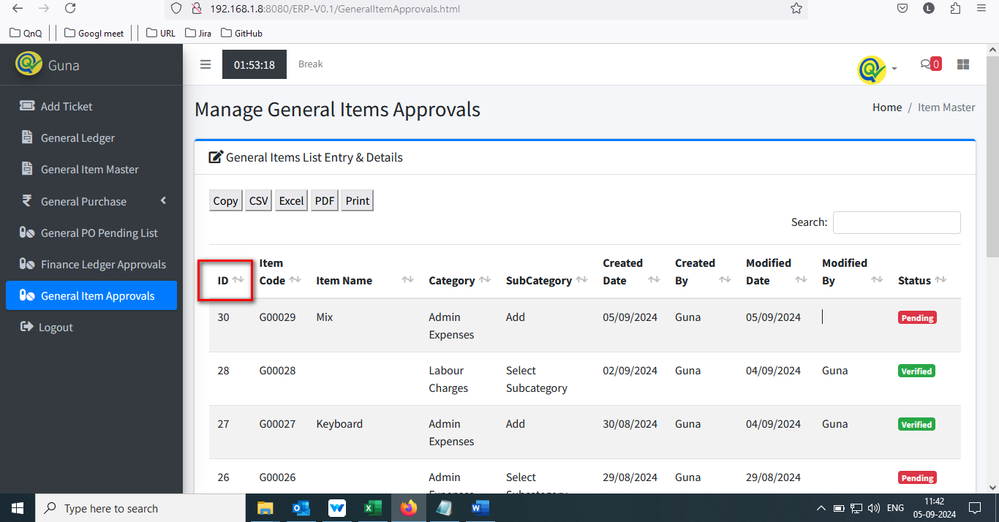

//

4. Placeholder or inner text not display in Search filter text box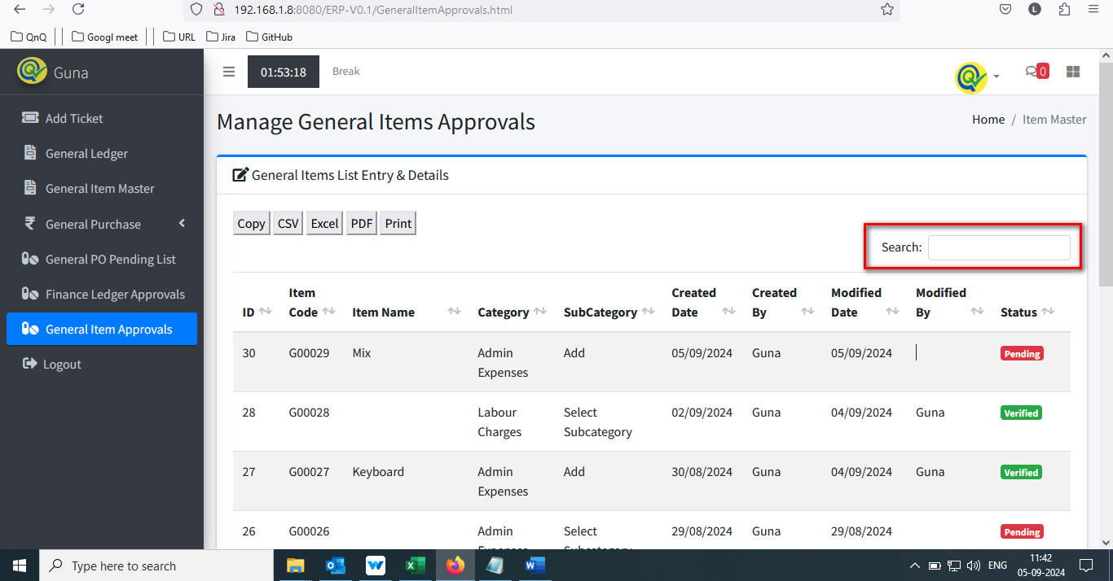

//

5. Icon's not display in download option section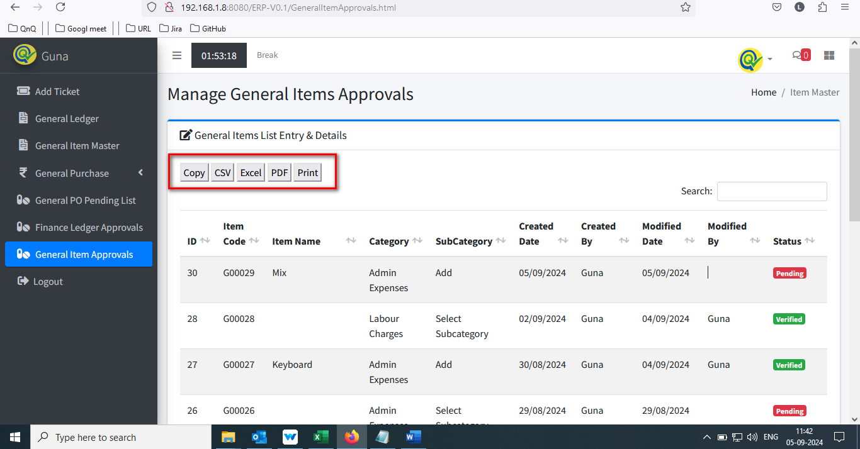

//

6. List grid display Improper border alignment 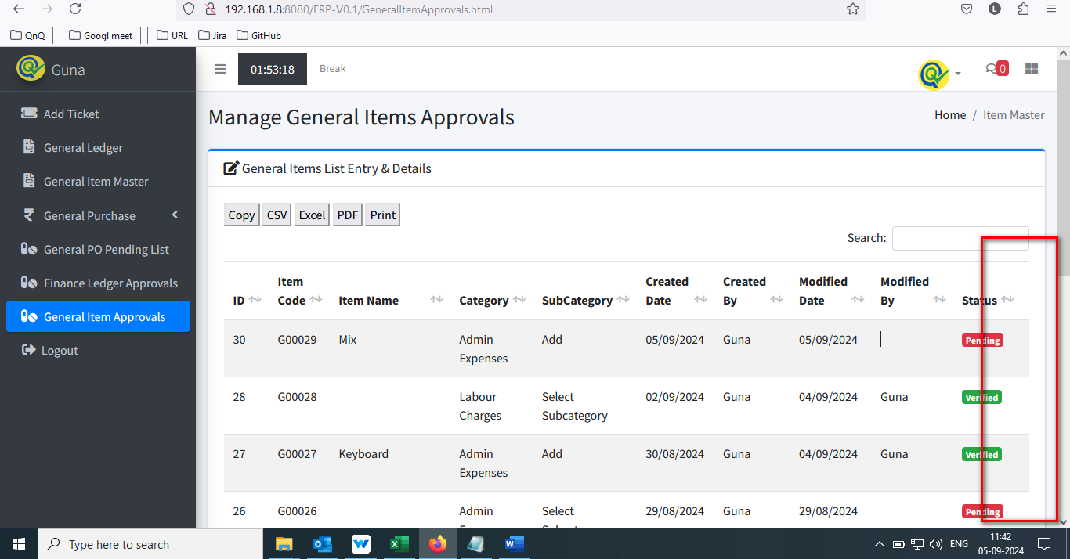

//

7. Unwanted column display in Item list grid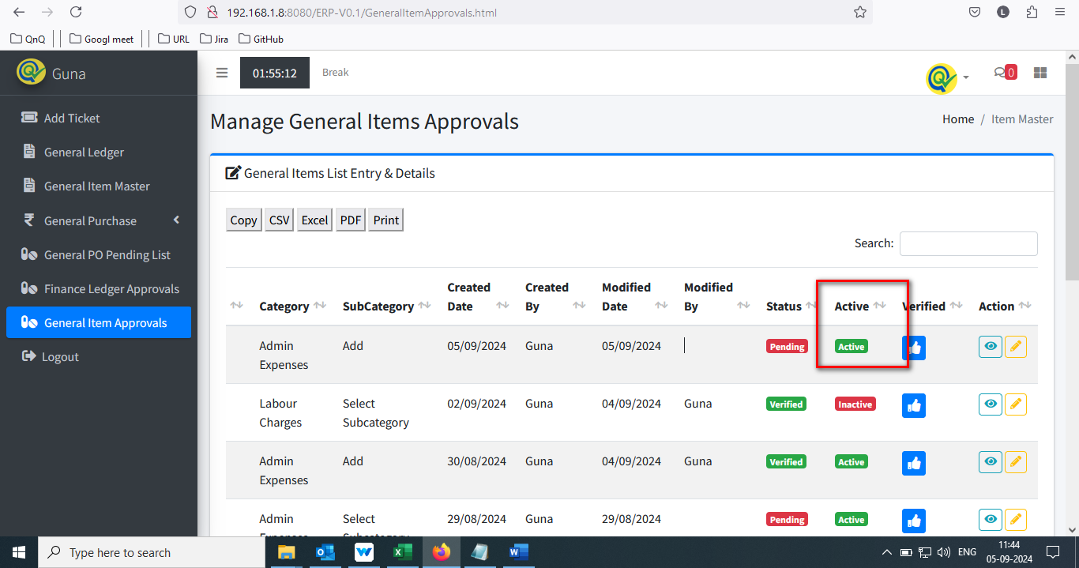

//

8. Icon not display in middle of the column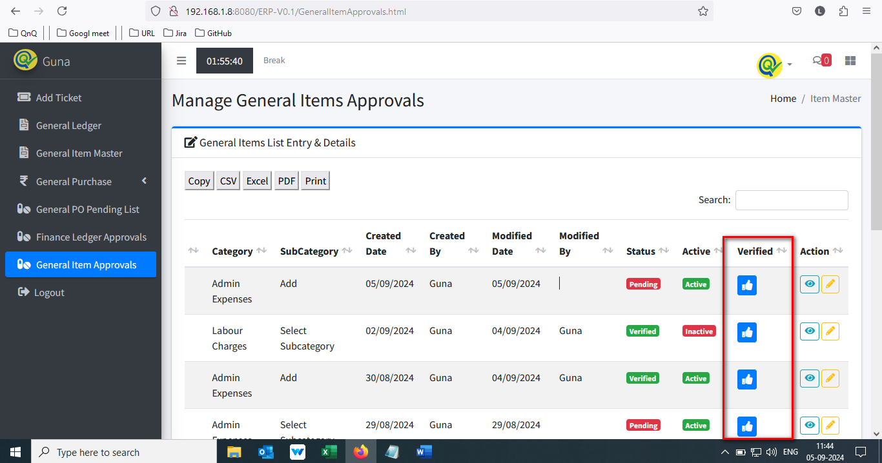

//

9. Column separator highlighted line not display in list grid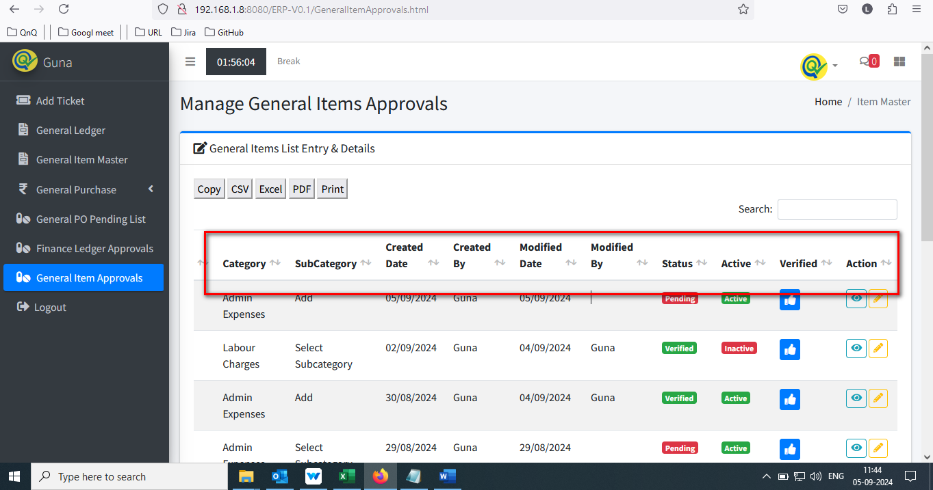

//

10. Sort icon display as too small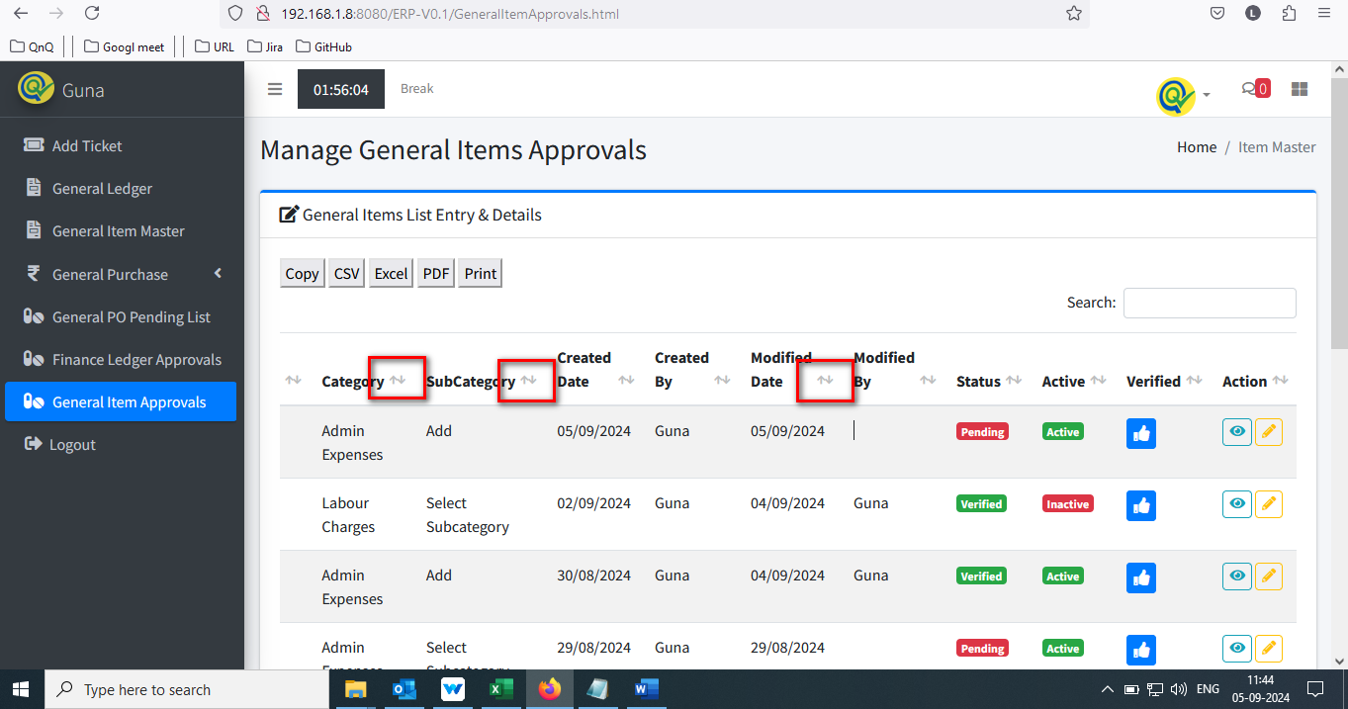

//

11.Improper alignment display in list grid while maximum value 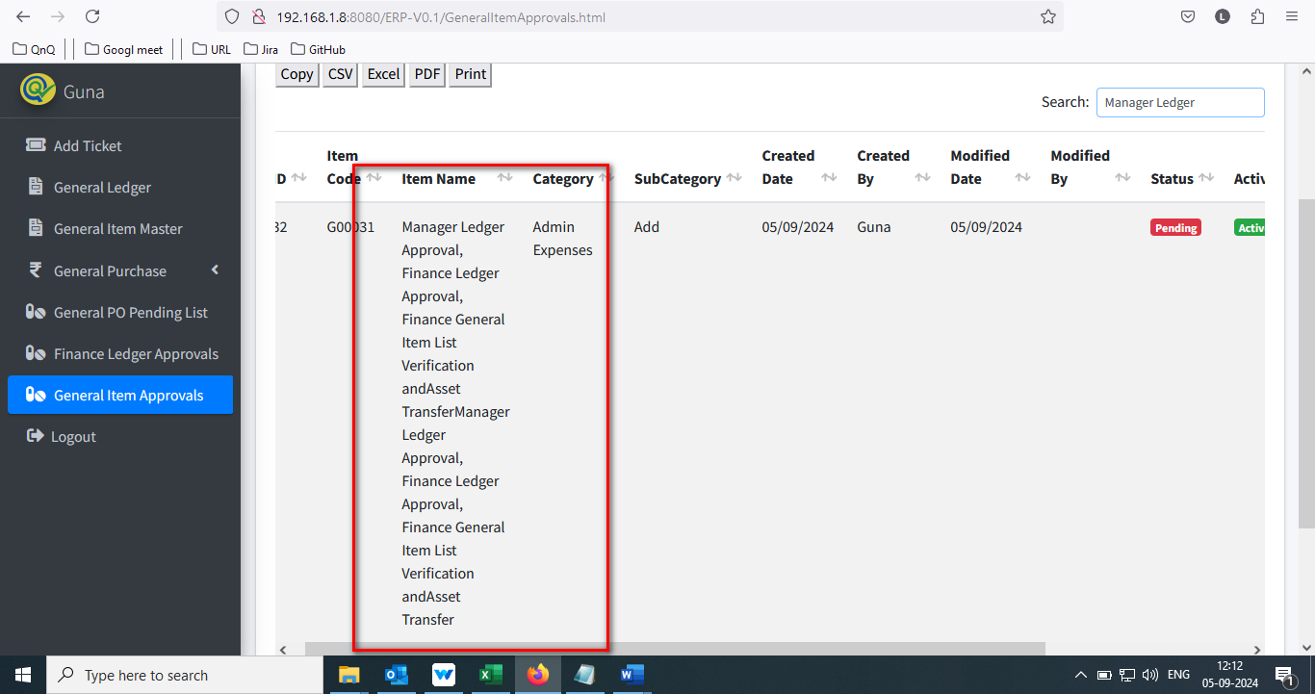

//

12. Duplicate record display in Ledger Approve list grid 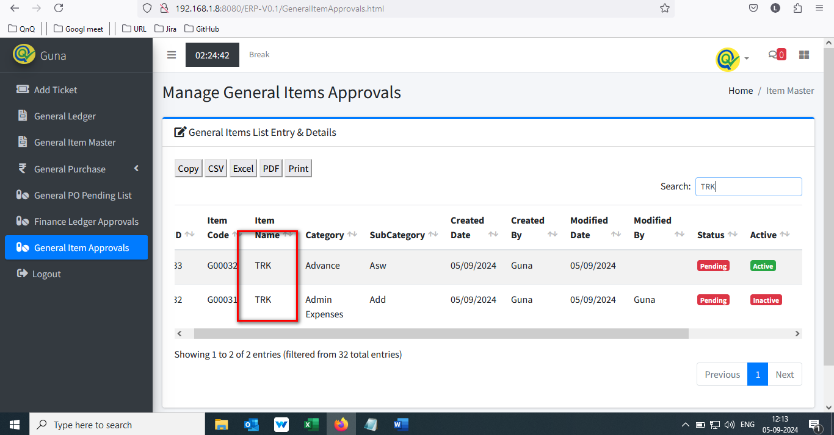

//

13. Showing count dropdown not display in in Finance General Item List Verification page 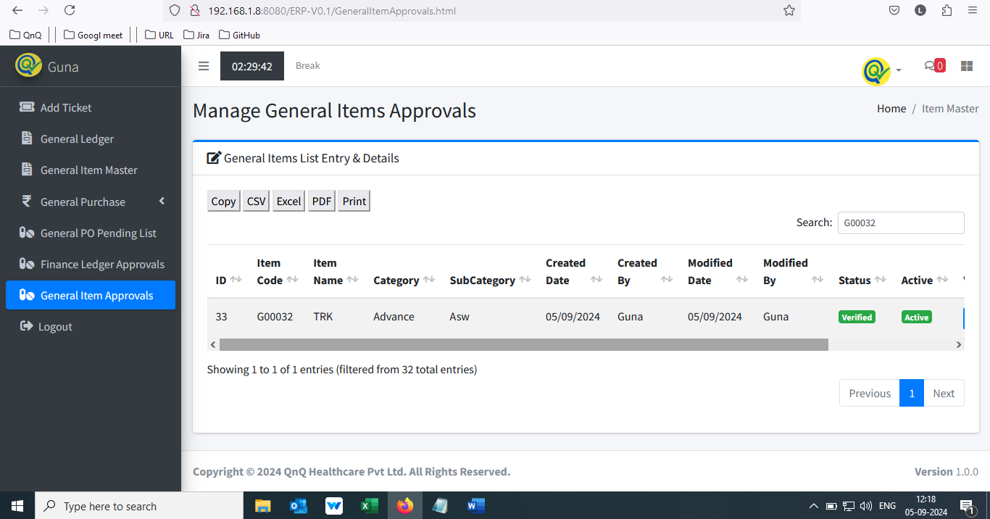

//

14. Inactive status record display in Ledger Approve list grid 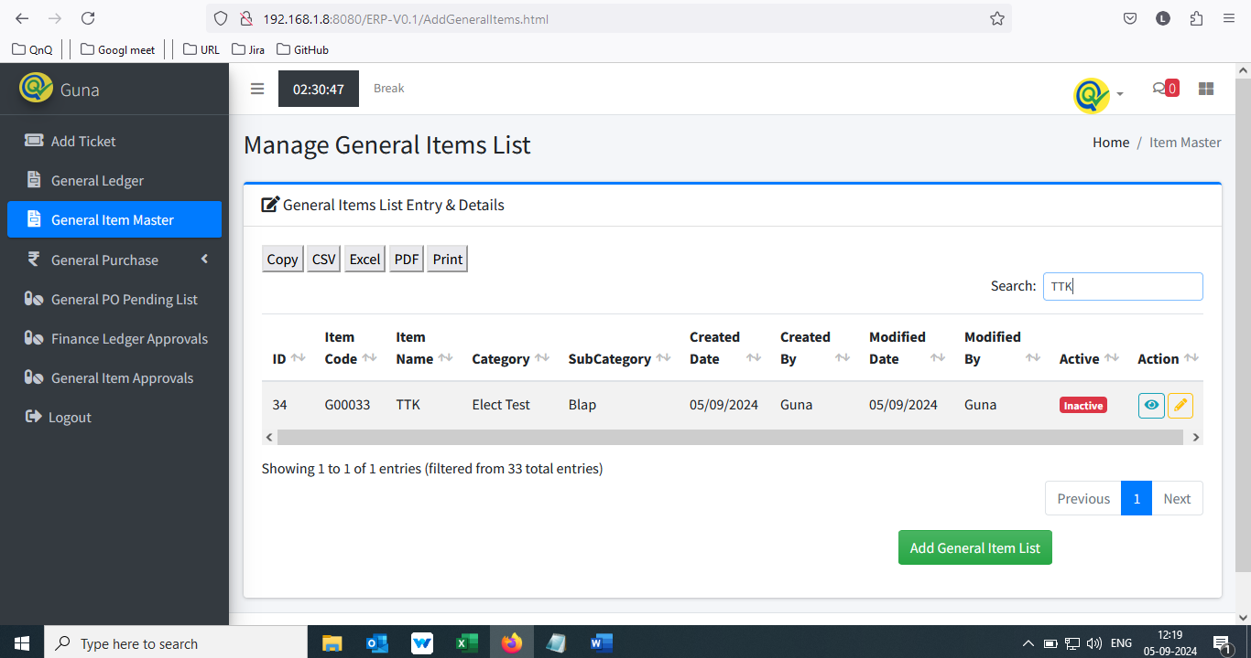 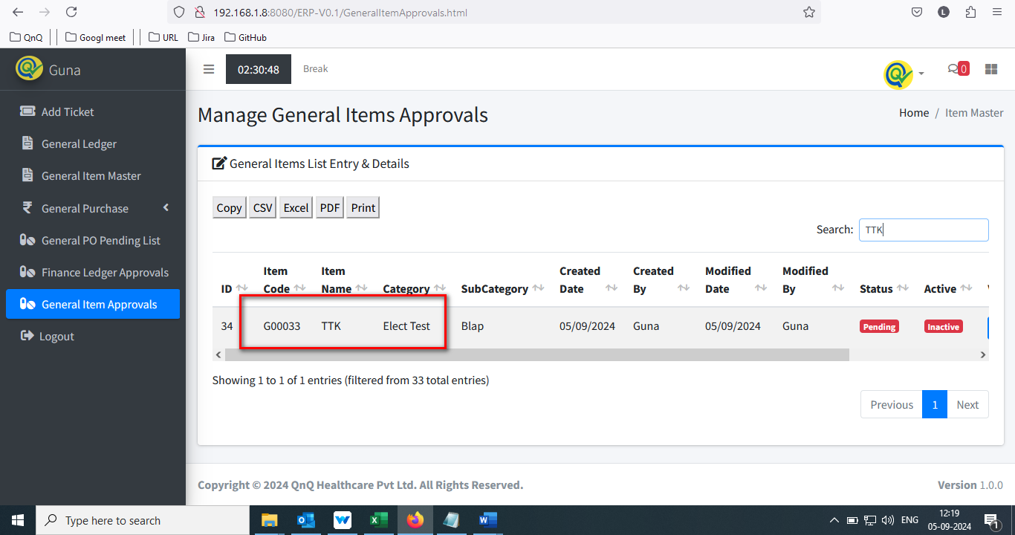

//

15. Approve edit form display mismatch value, which value update in Item master 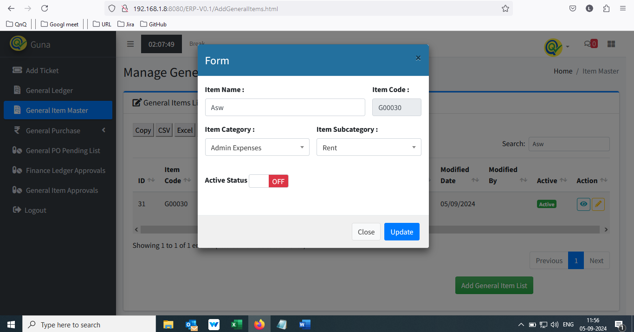 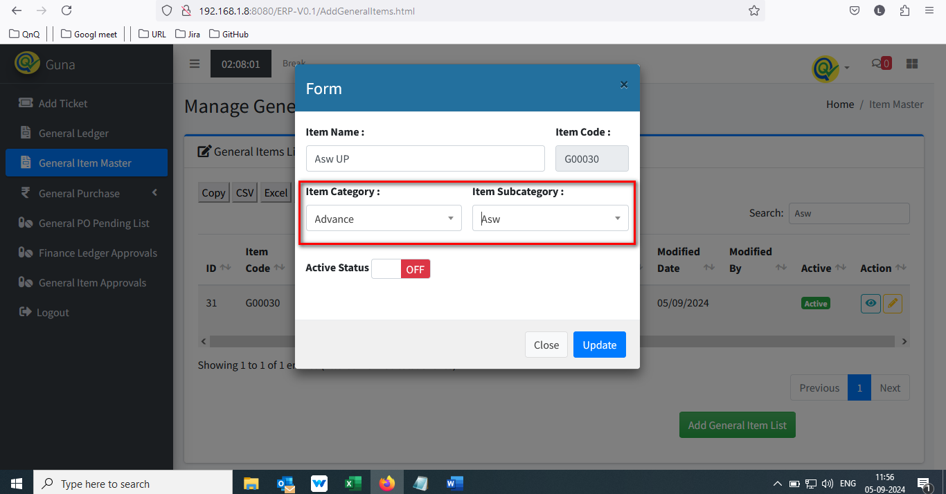 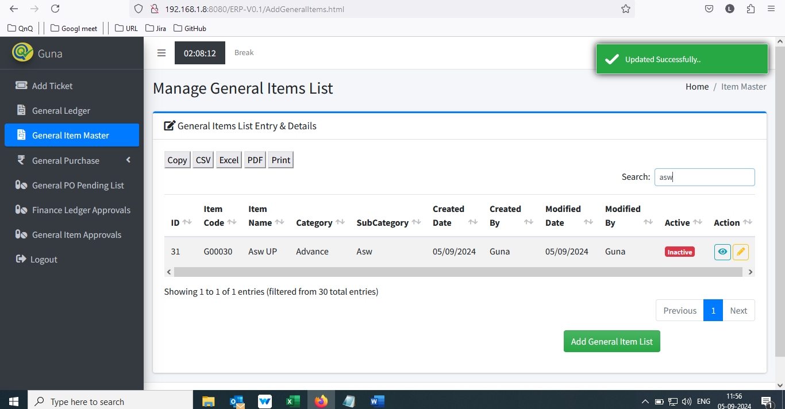 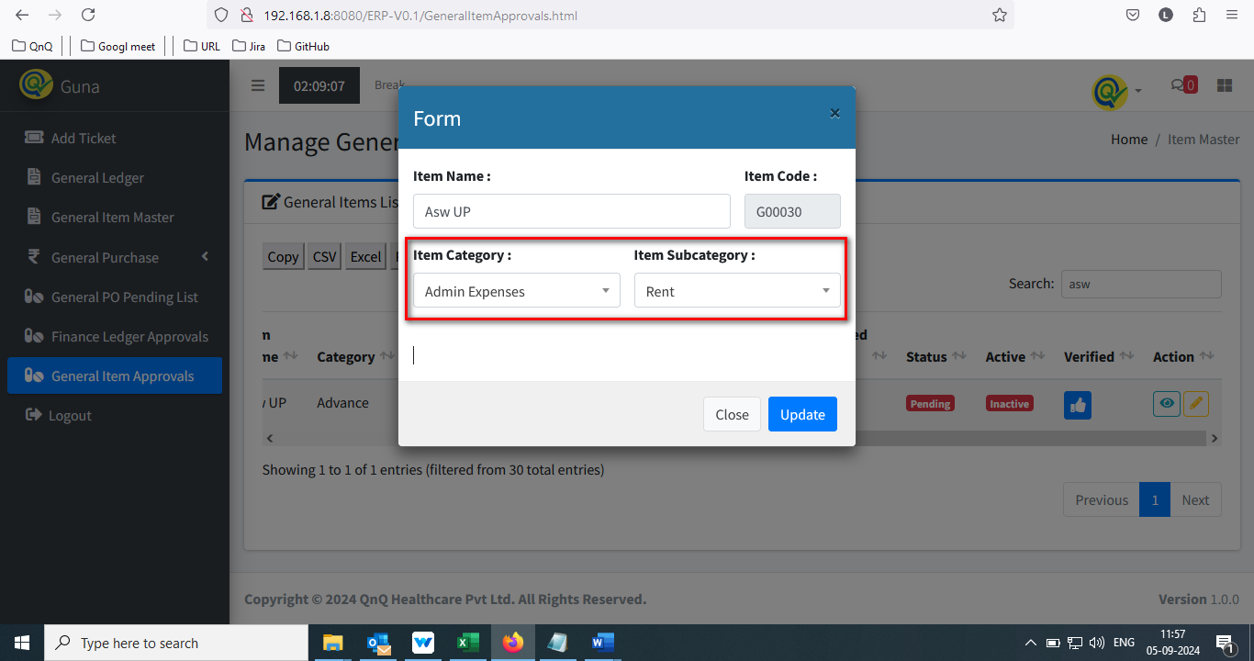

//

16. Dual success message display while update the record 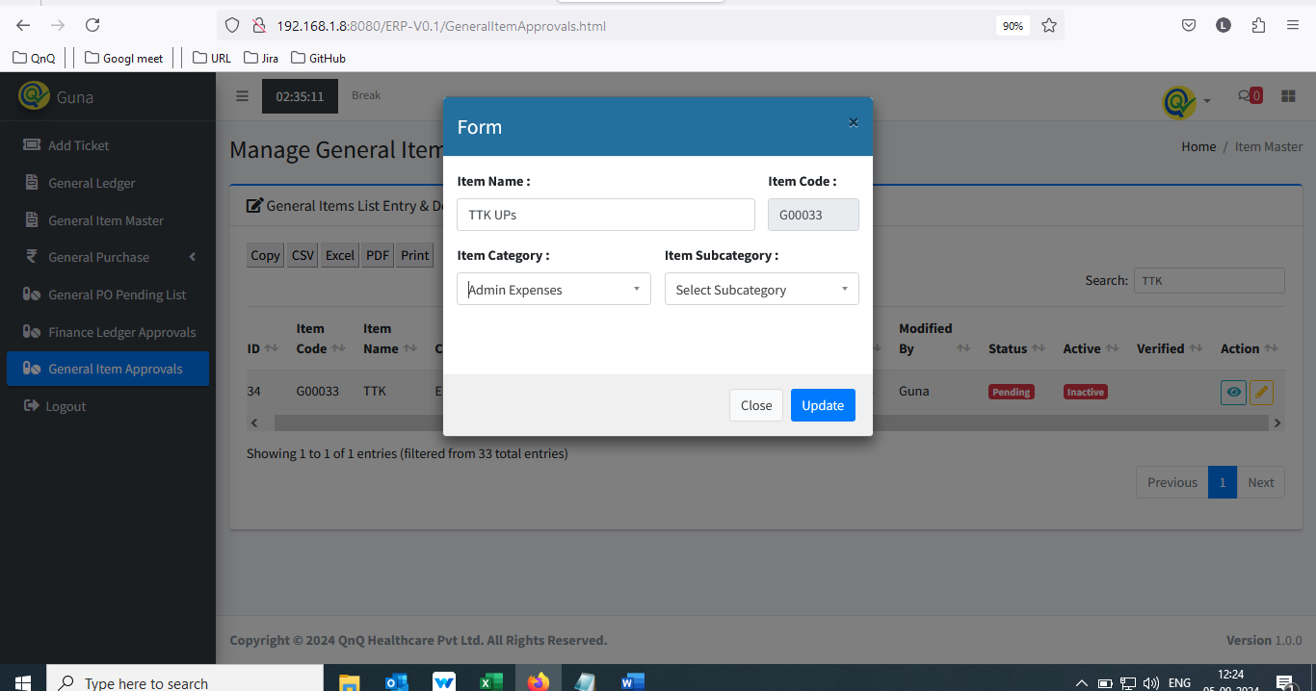 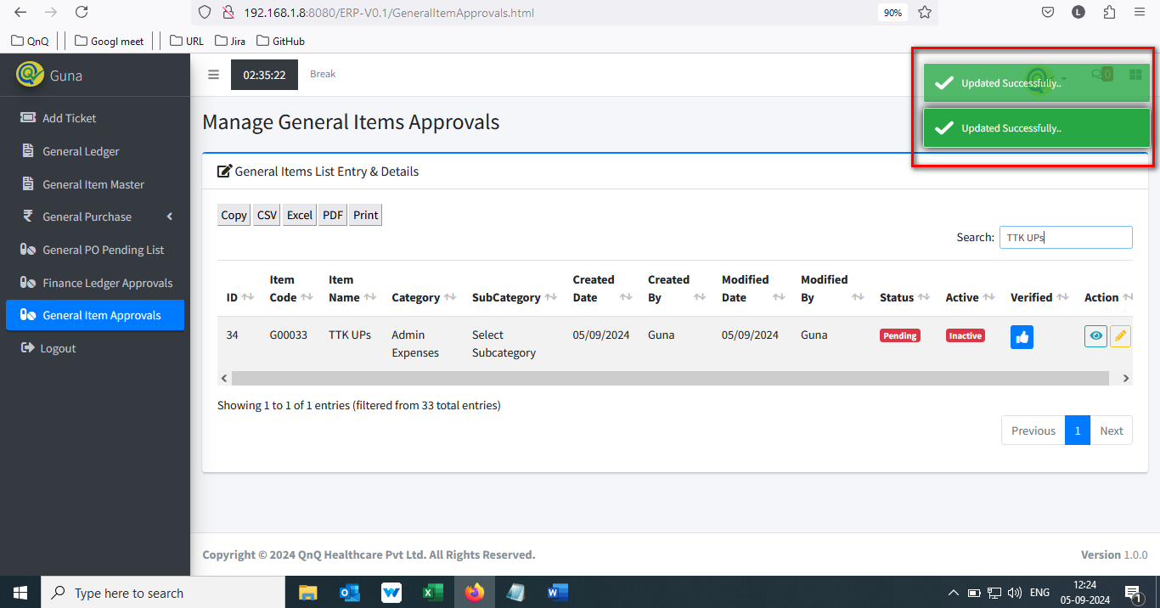

//

17. System loading for long time while click the Print button 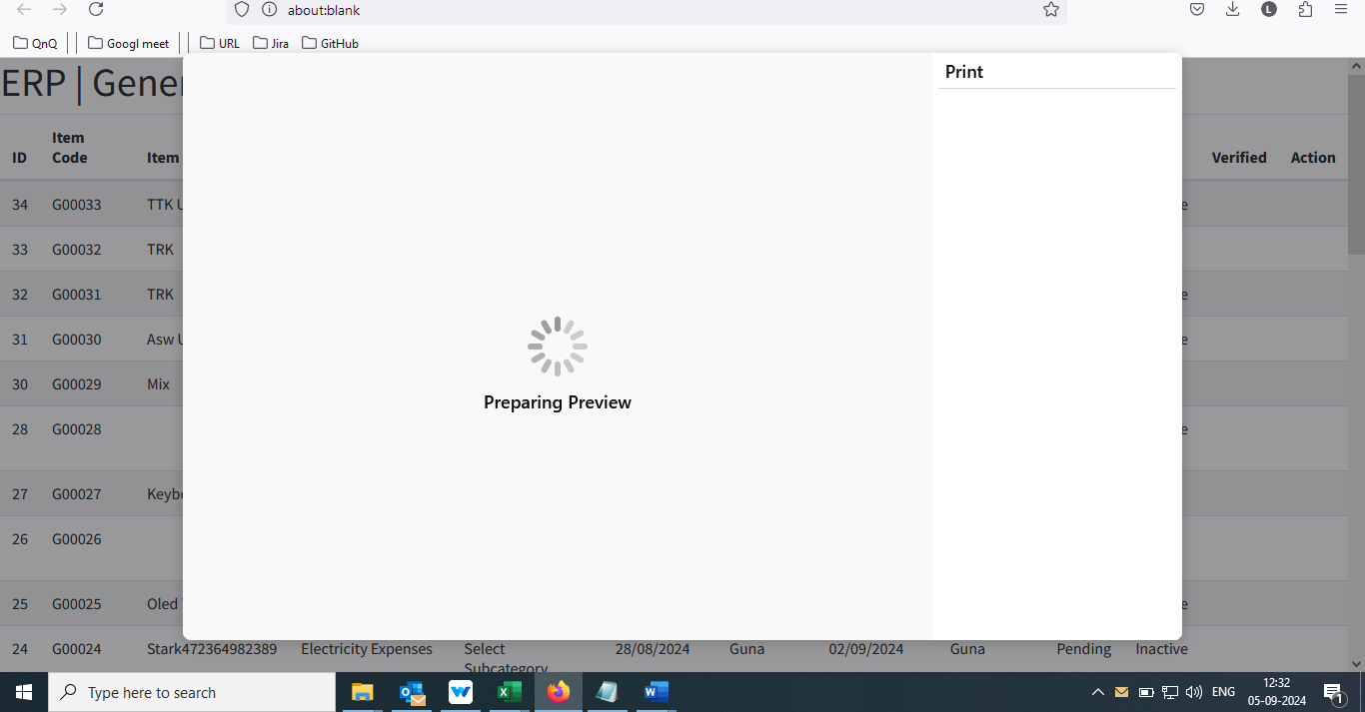

//

18. Updated value not display in item approve edit pop up 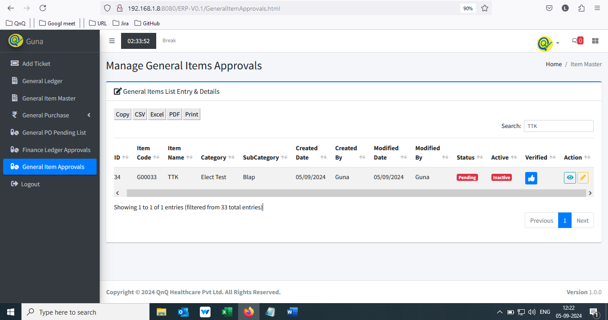 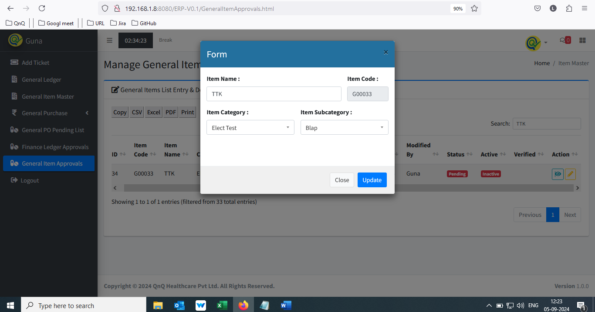  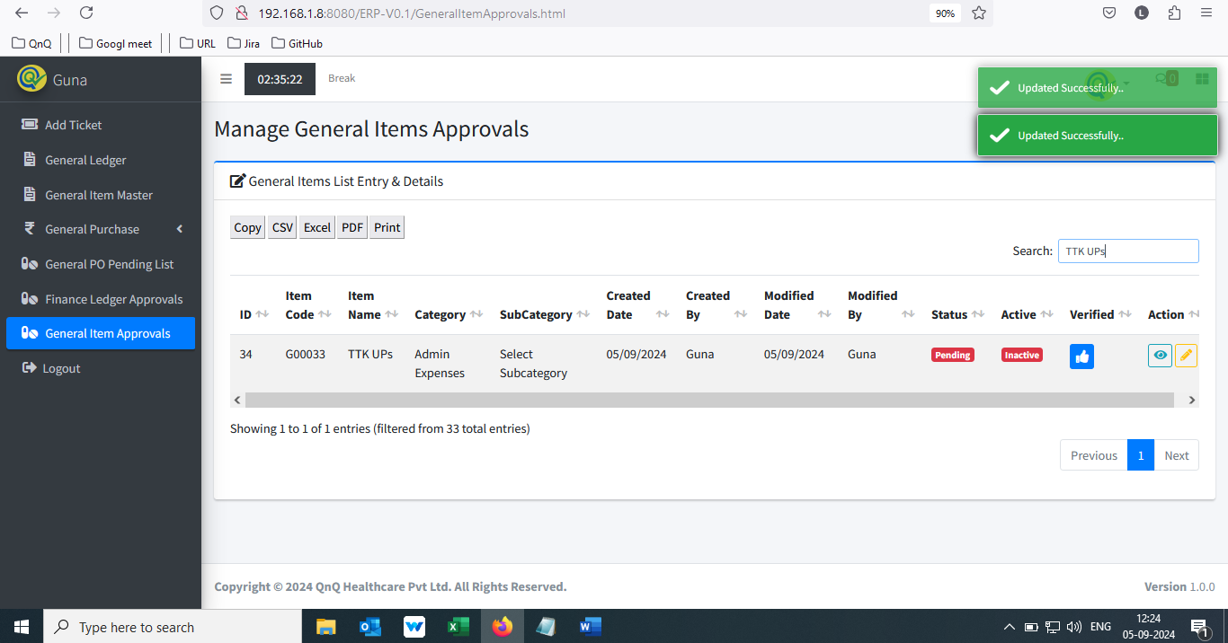 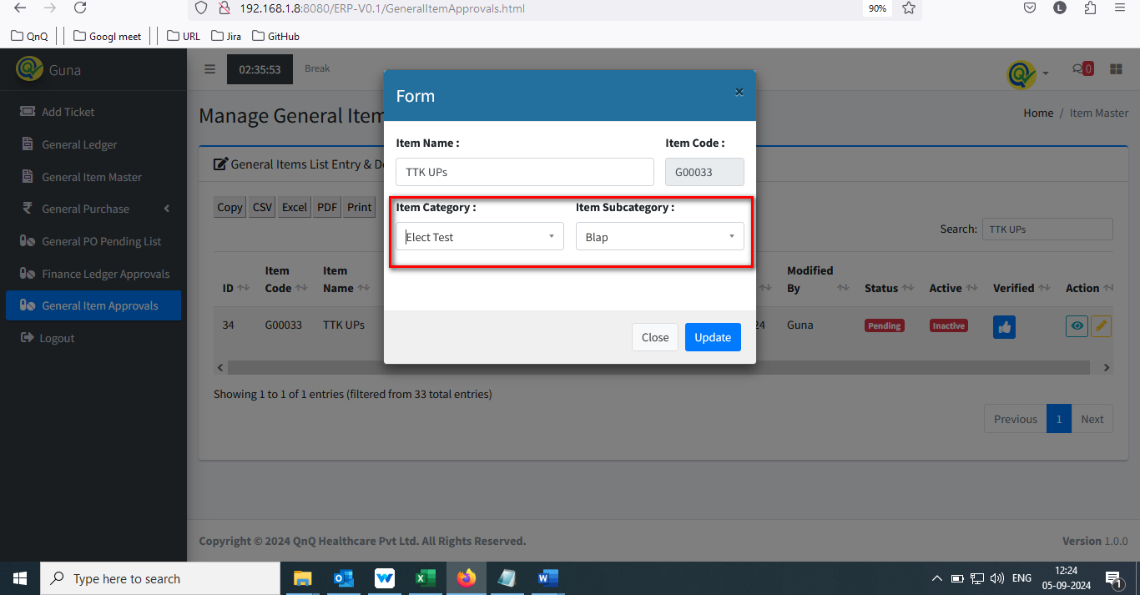

//

19. Approved status not getting reflect in Item master screen 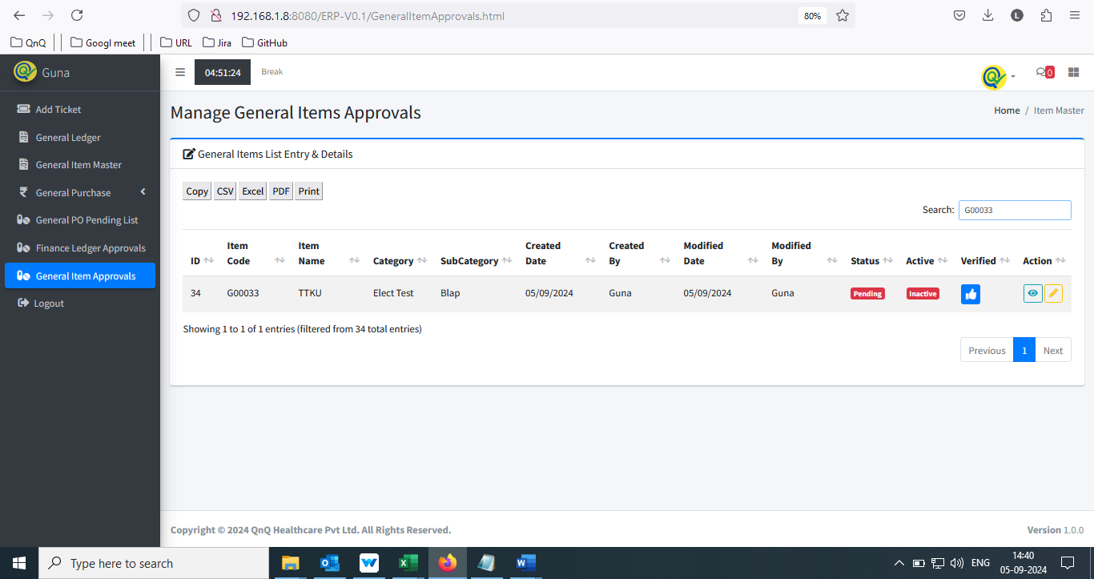 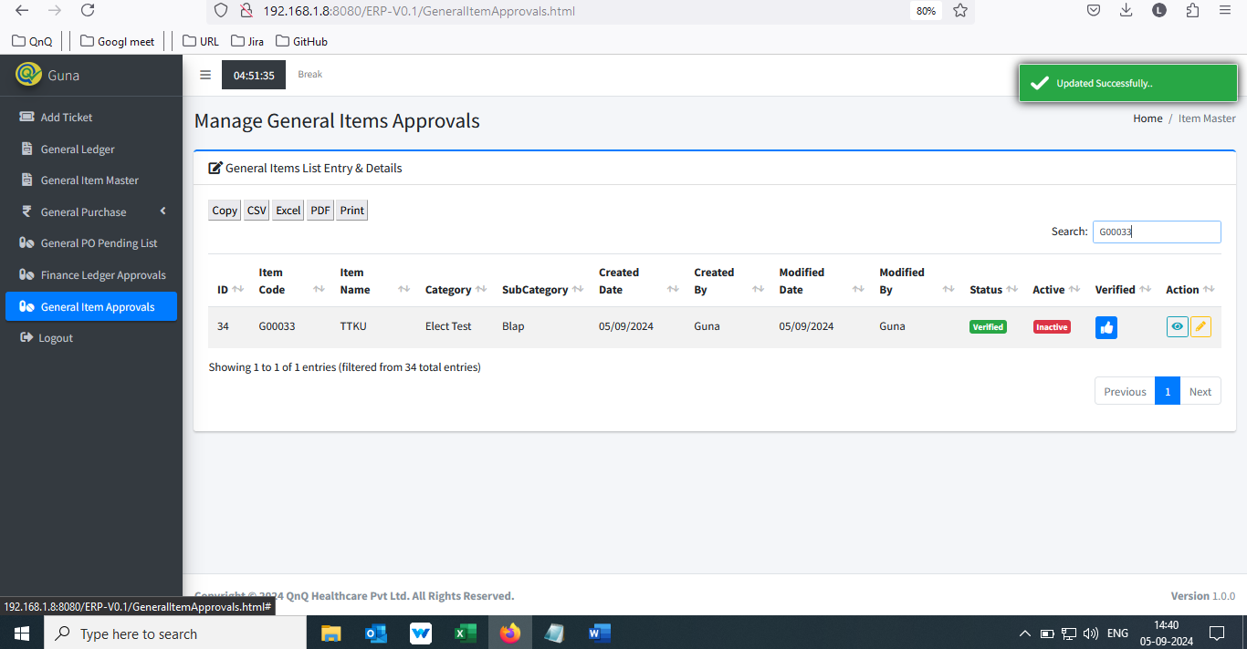 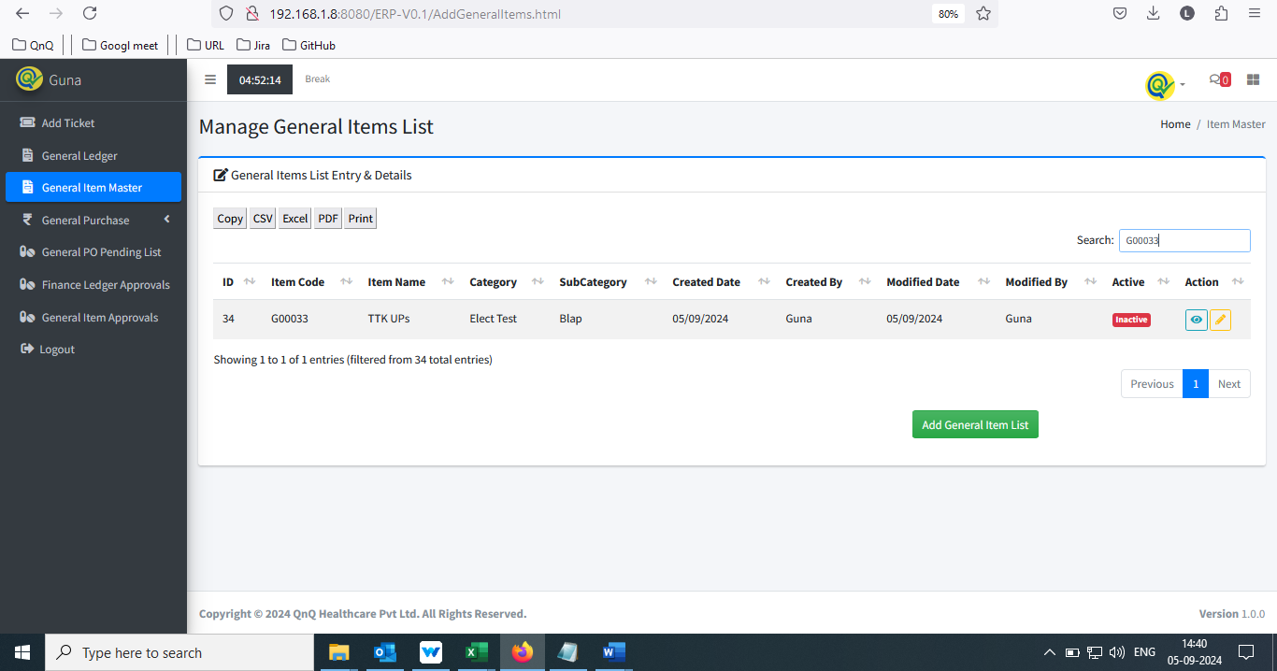

//

20. Navigation section display mismatch value 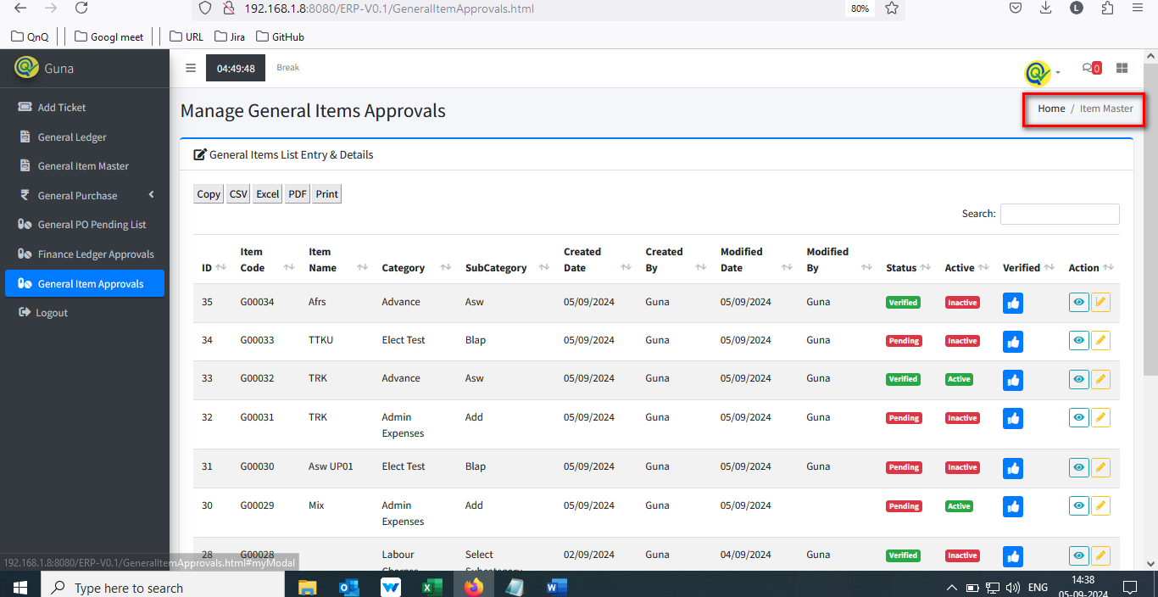

//

21. Mismatch pop up title display 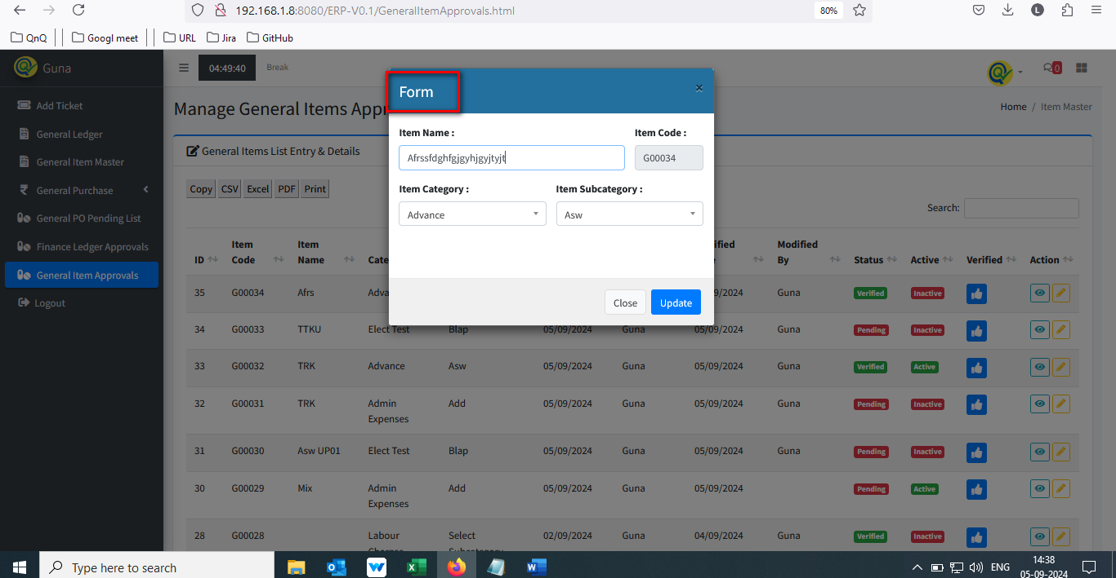

//

22. Close icon not display properly 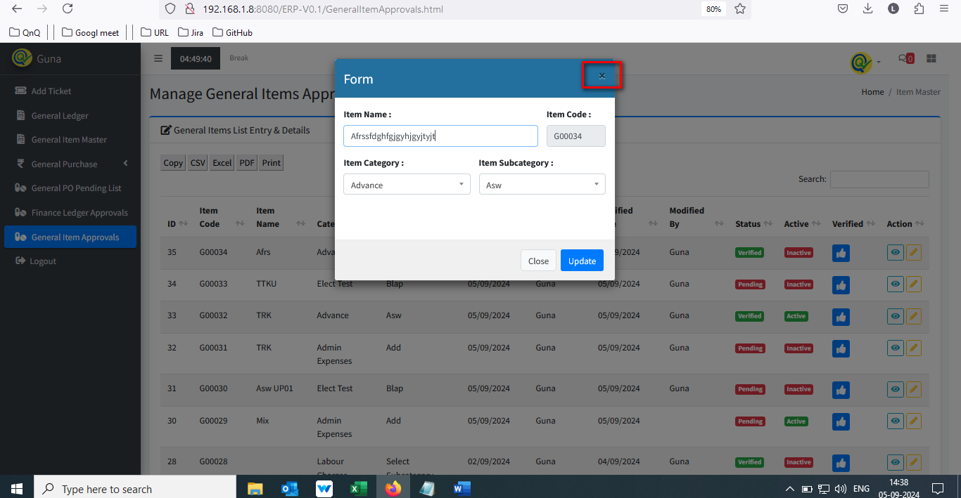

//

23. Confirmation message not display while close the pop up with all values 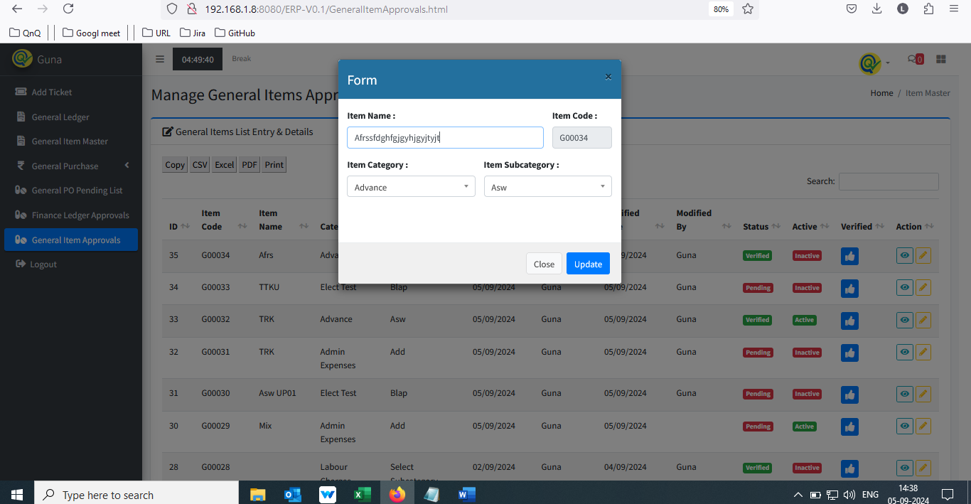 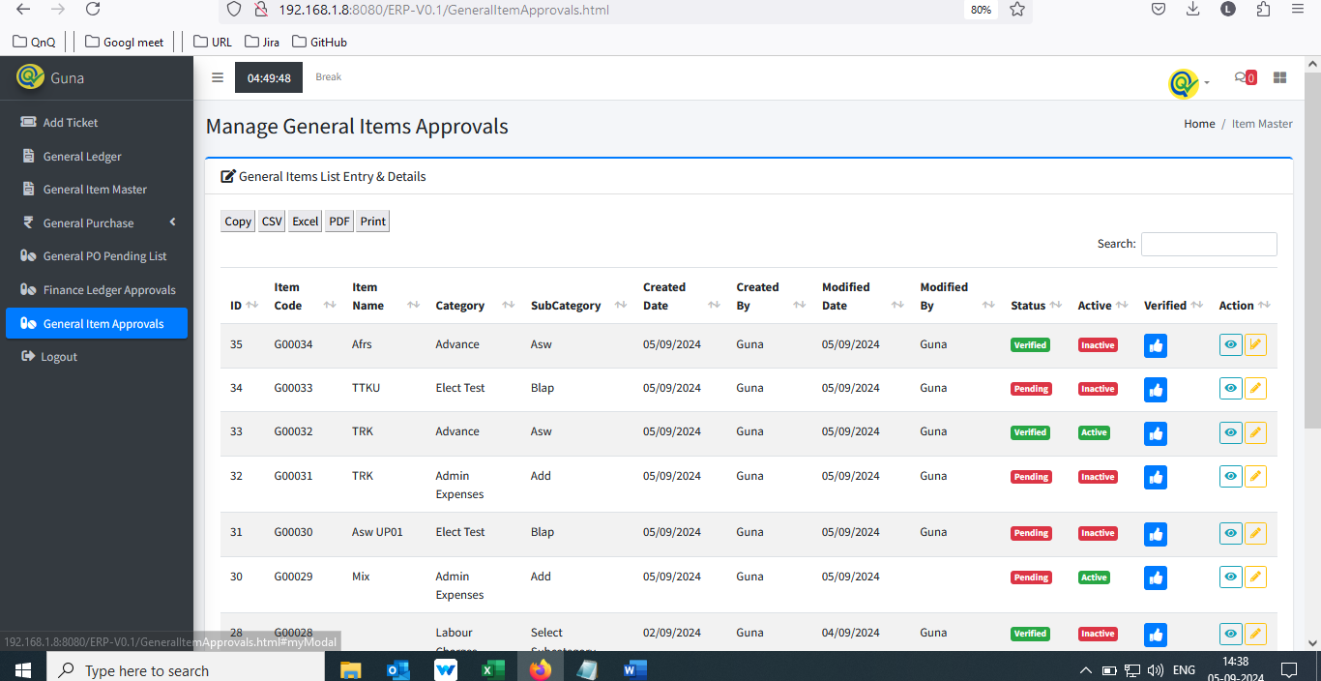

//

24. Update pop up getting close while click beyond the pop up 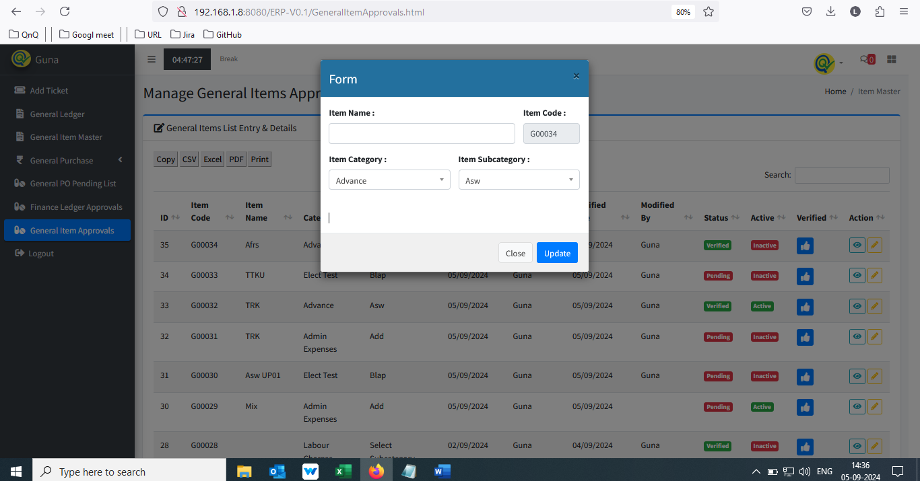 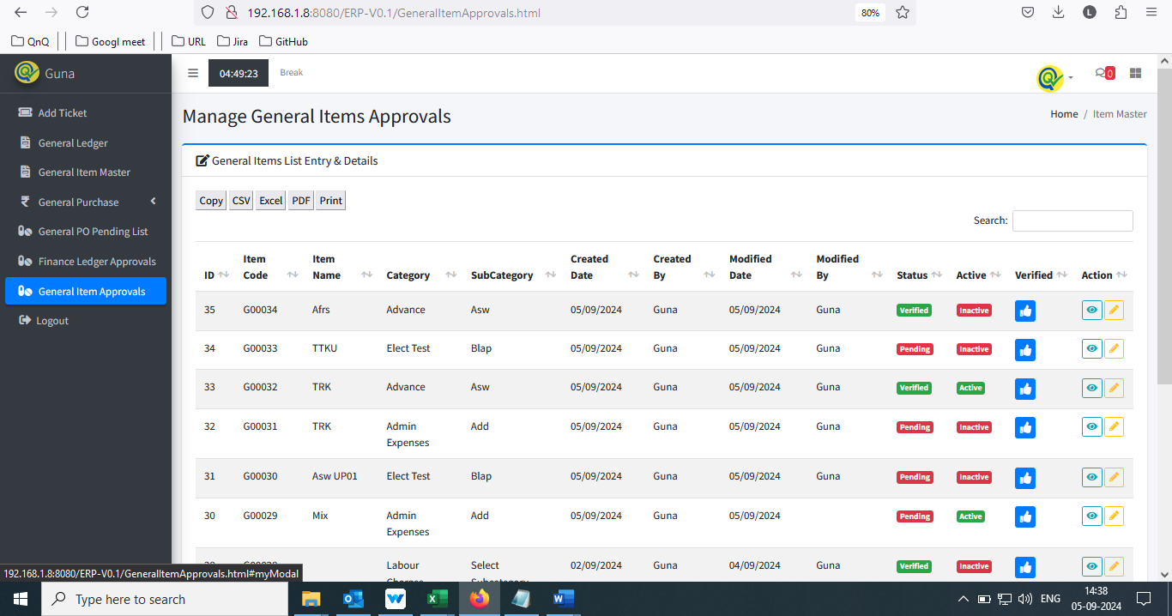 //

25. Tool tip not display for Close icon 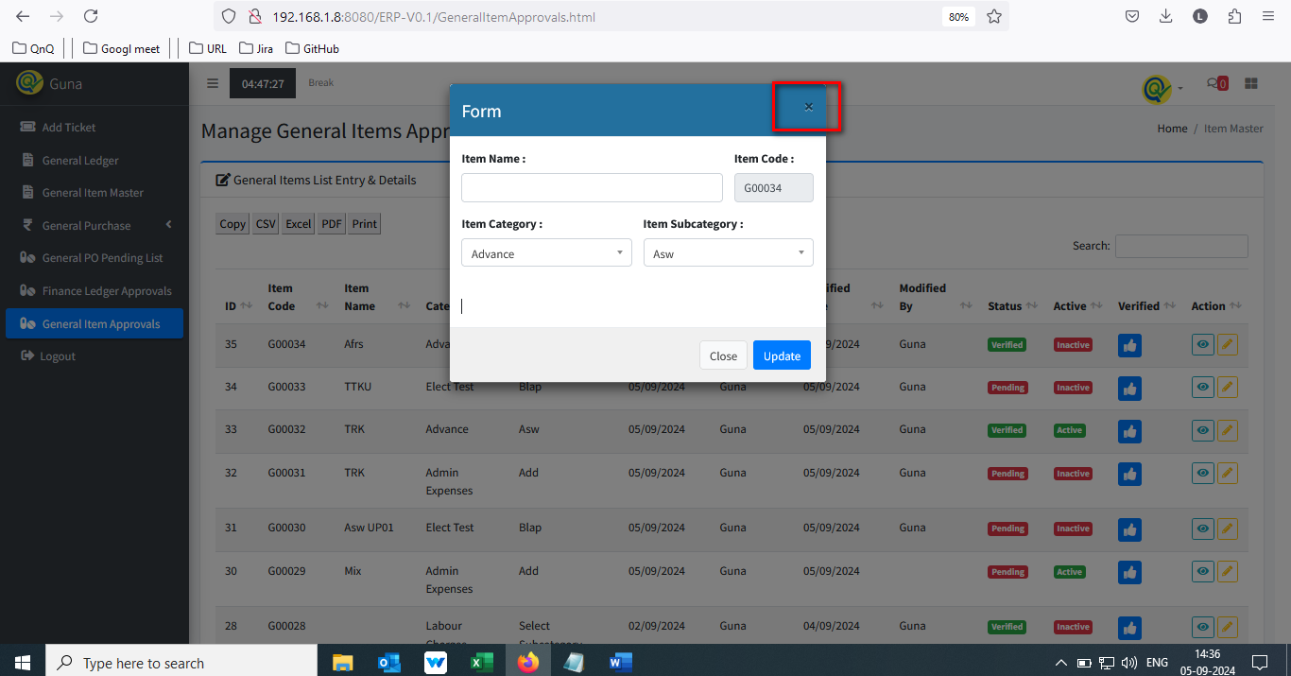

//

26. Placeholder or inner text not display in Remarks field 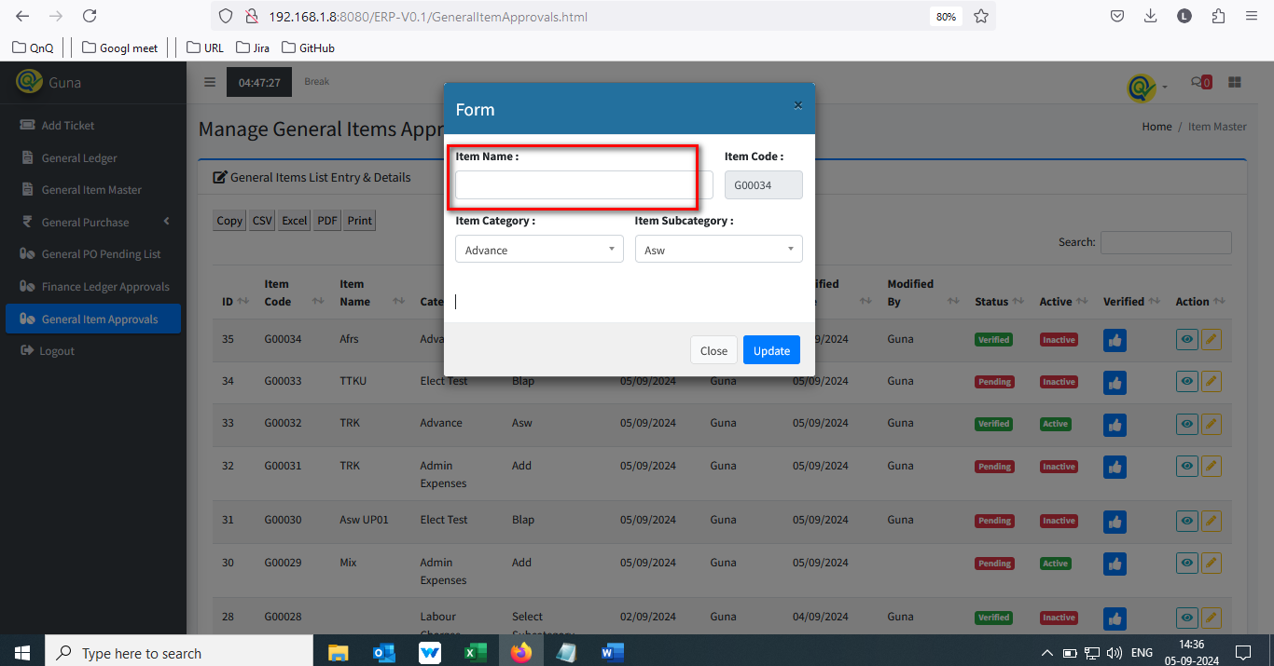

//

27. Update message display mismatch content 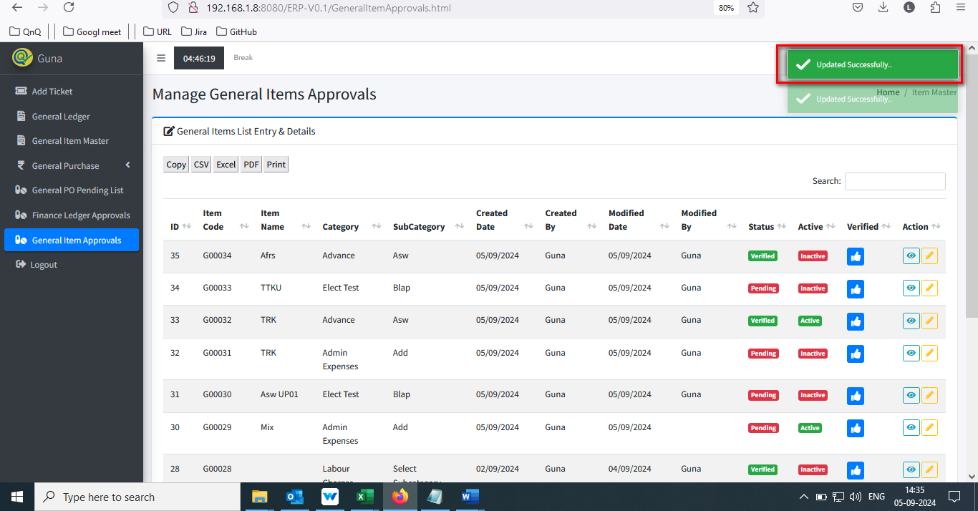

//

28. Updated success message display without update any value 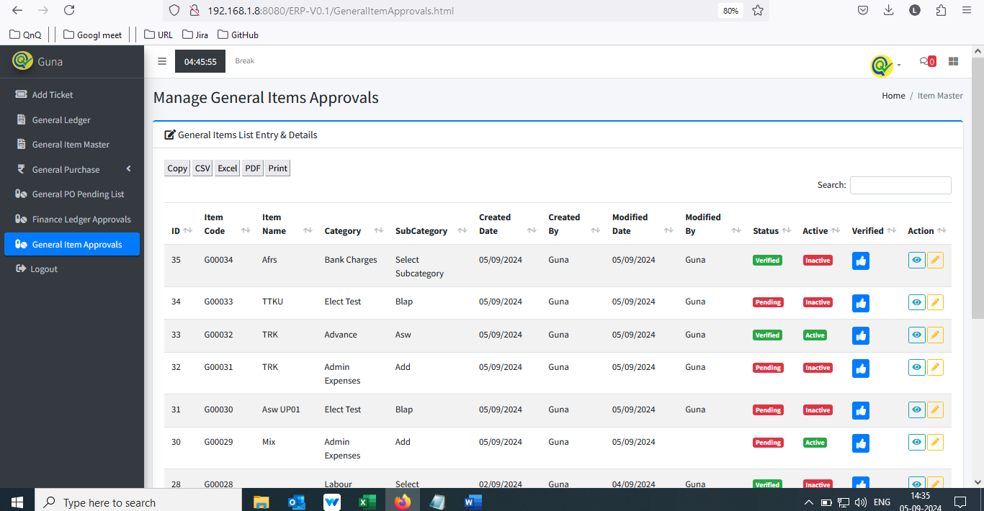 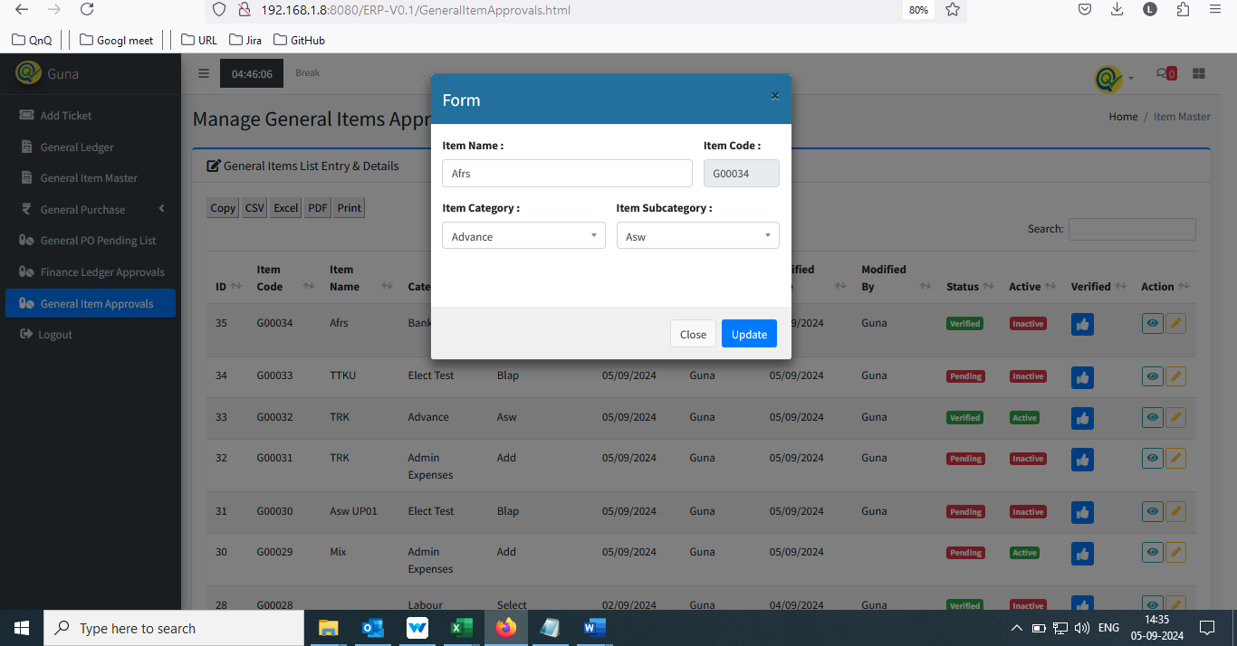 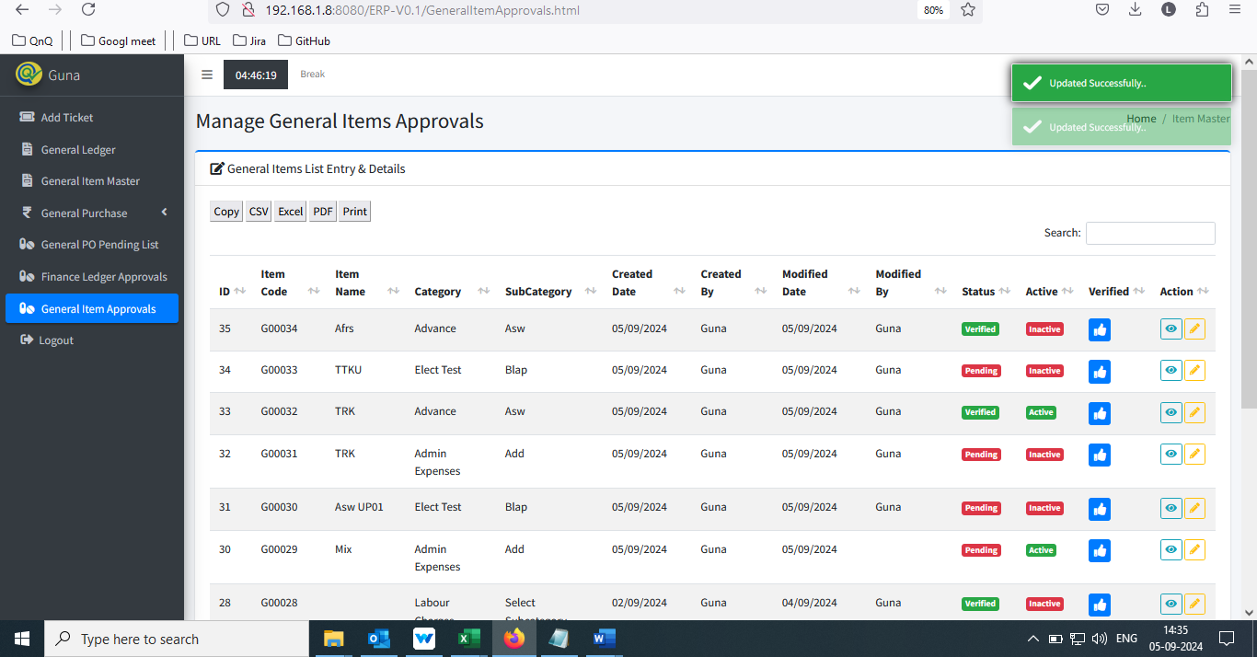

//

29. User can able to give values in all field value in view pop up 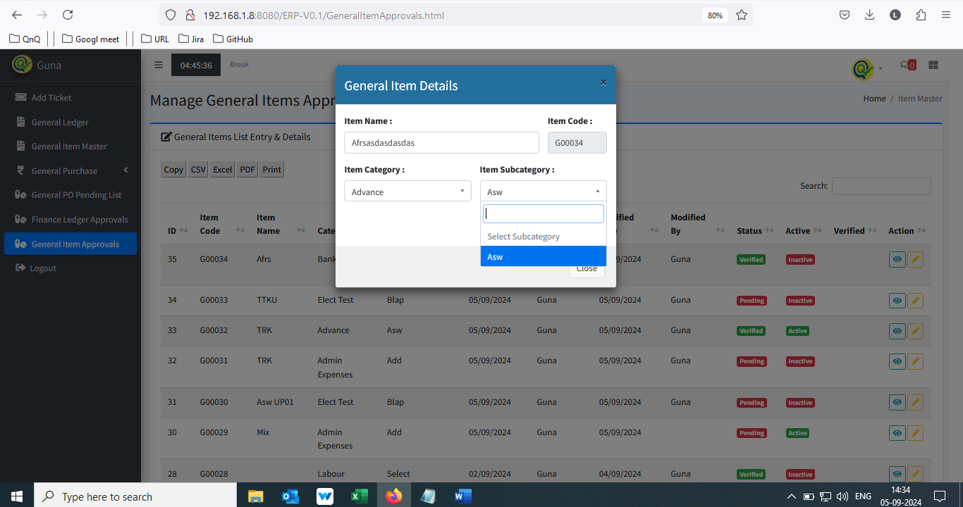

//

30. First letter display as small letter in tool tip 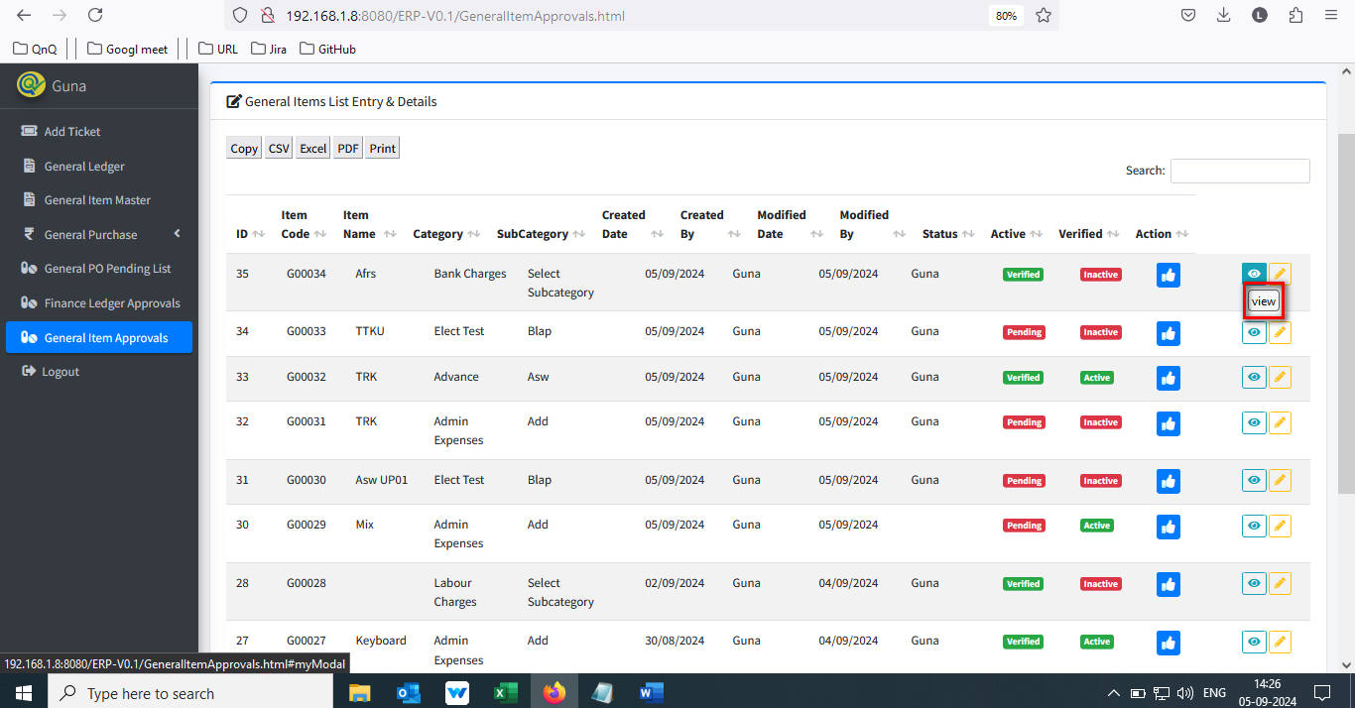 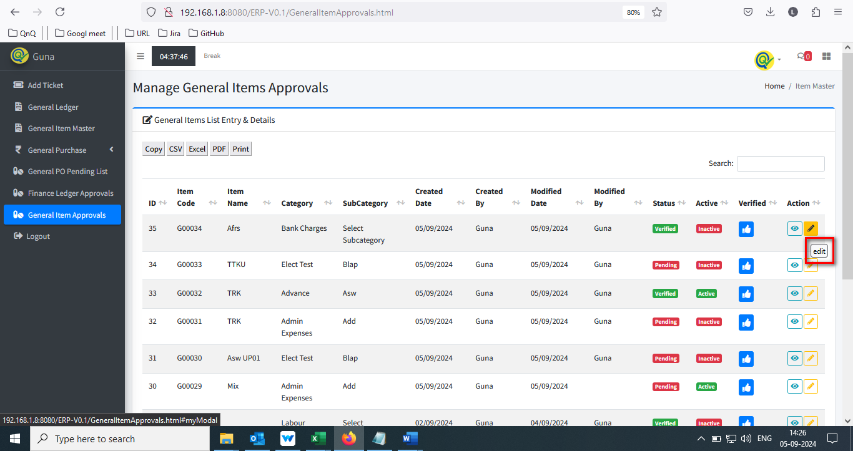

//

31. Dropdown values display beyond the pop up 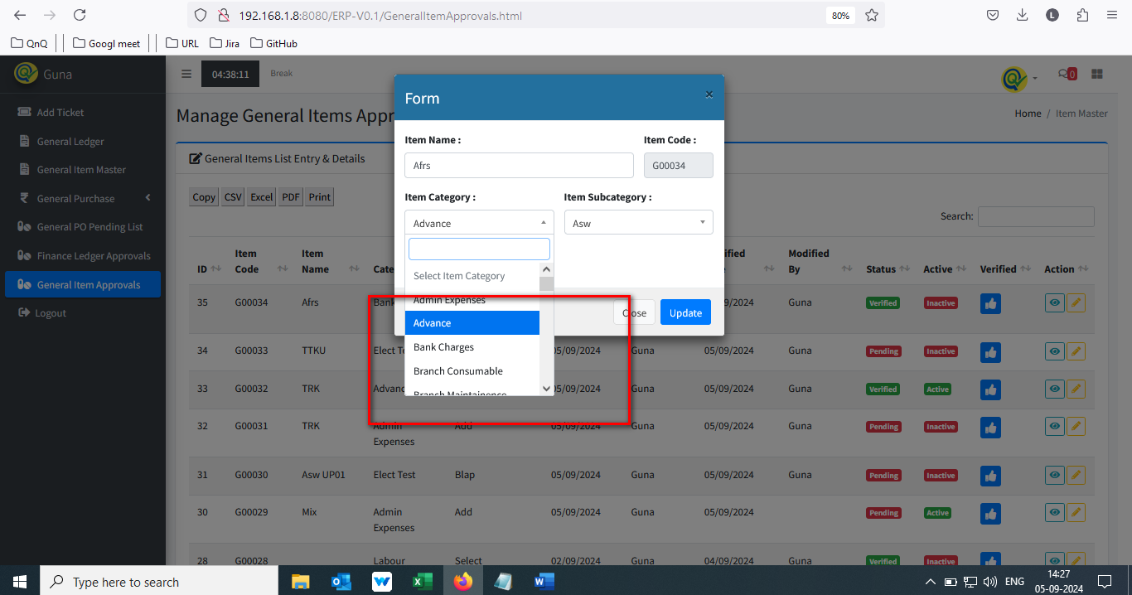

//

32. System allow ro approve multiple time for the same record

//

33. Improper alignment display in Item approve PDF document 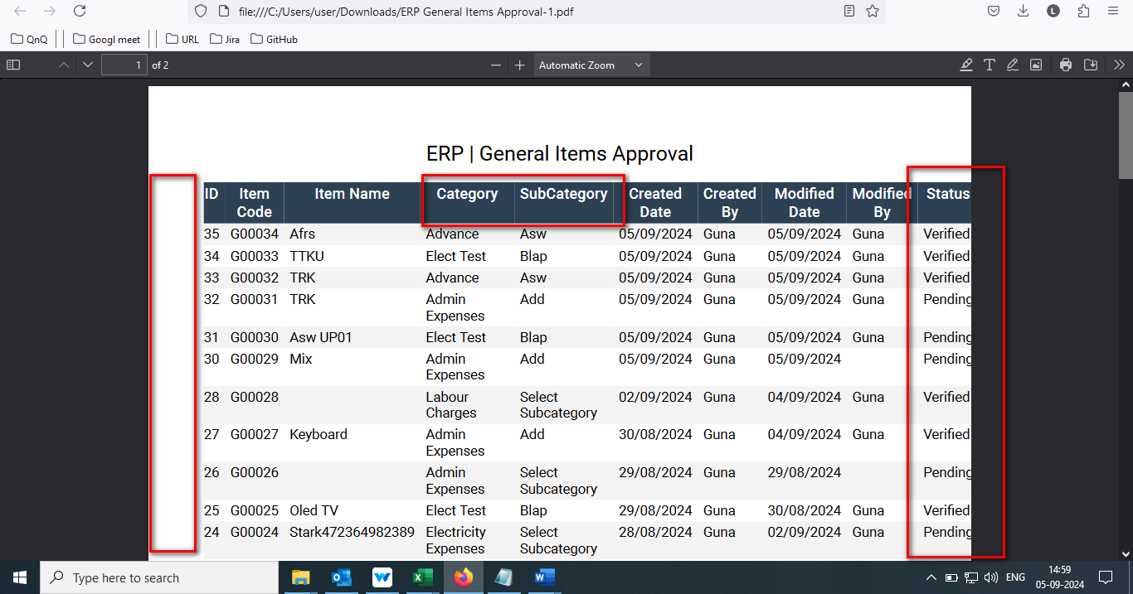

//

34. Mismatch title value display in Item approve PDF document 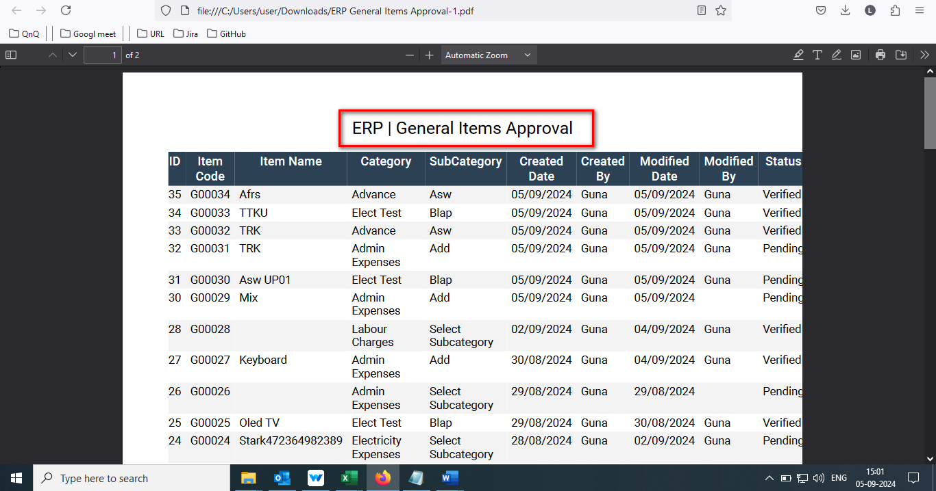

//

35. Null value display in Item approve PDF document 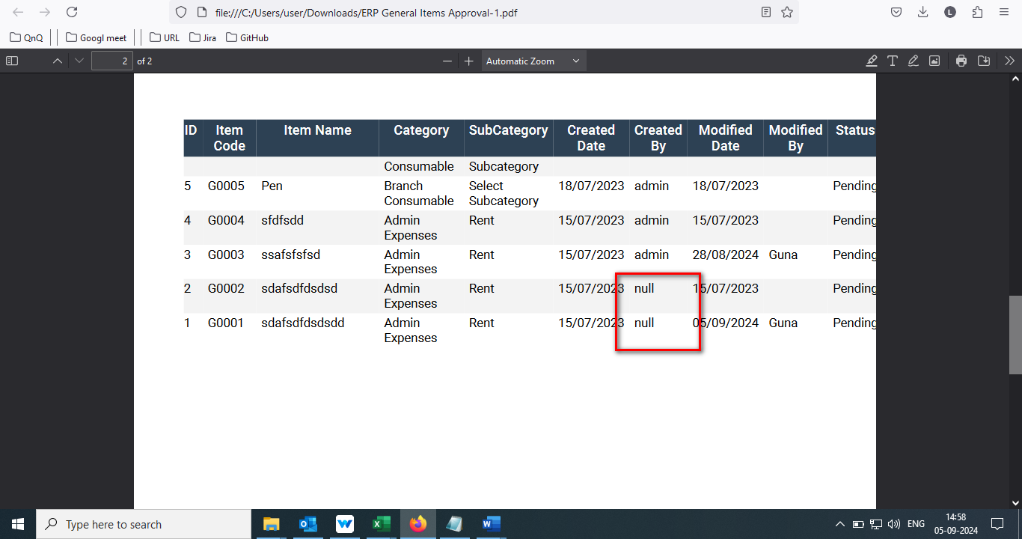

//

36. Error message display while open the Finance General Item List Verification CSV file 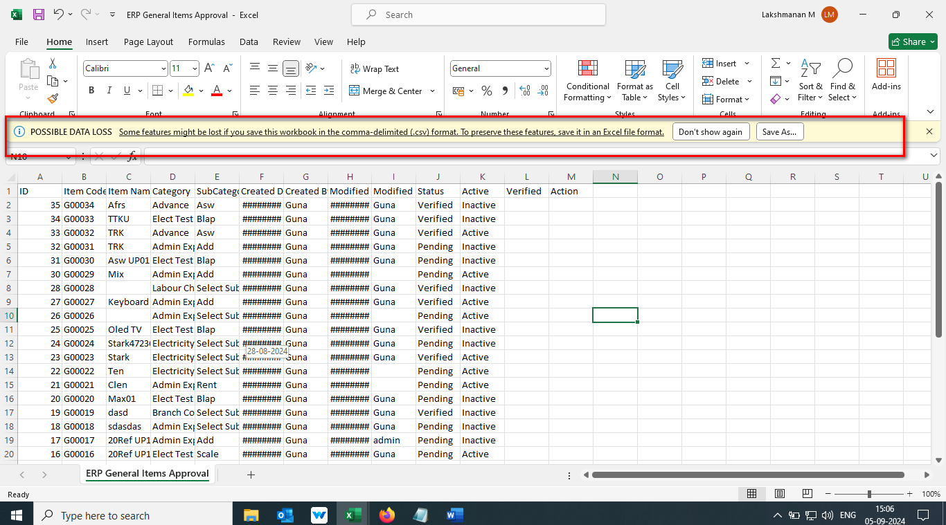

//

37. Hash (#) value display while open the Finance General Item List Verification CSV file 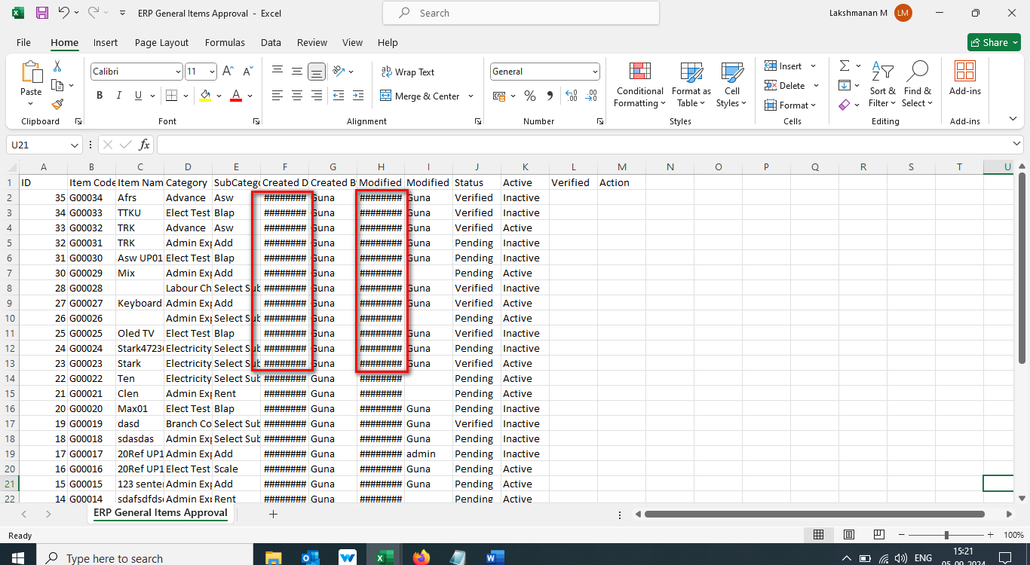

//

38. Header column not display properly in Finance General Item List Verification CSV file 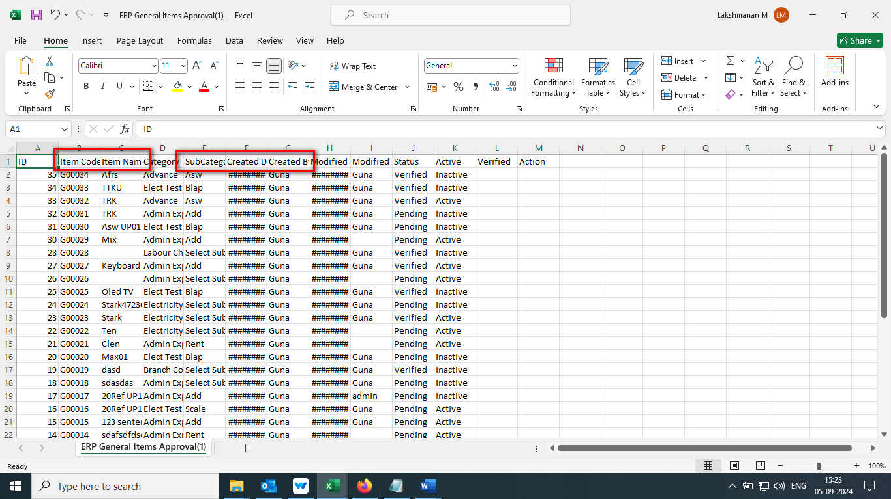

//

39. Header column display as normal column in Finance General Item List Verification CSV file 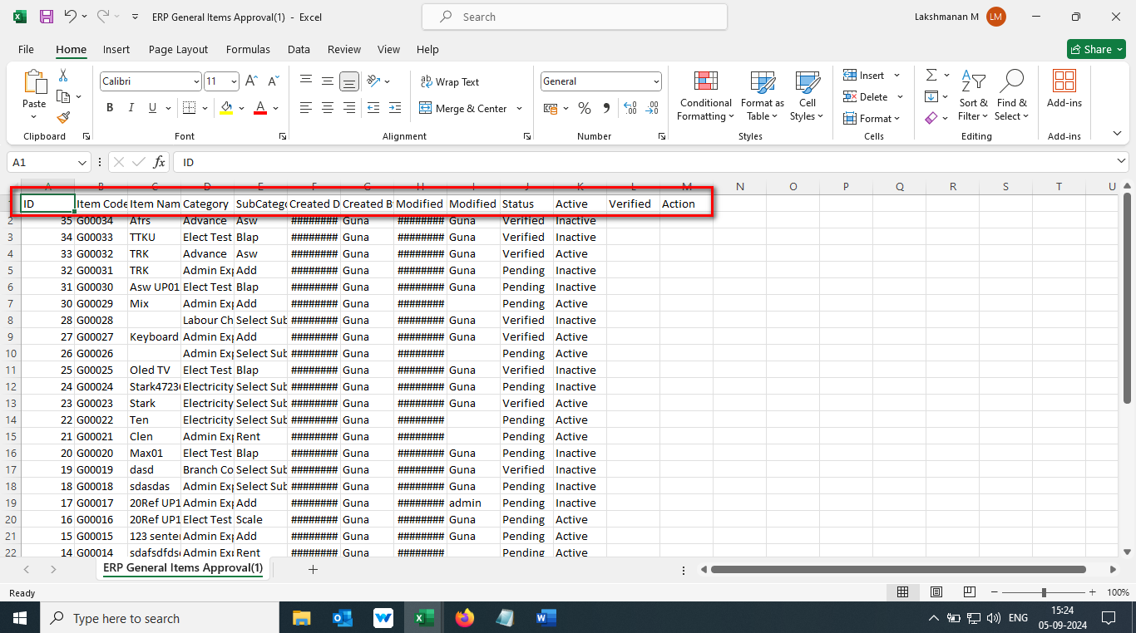

//

40. Given value not display properly in Finance General Item List Verification CSV file 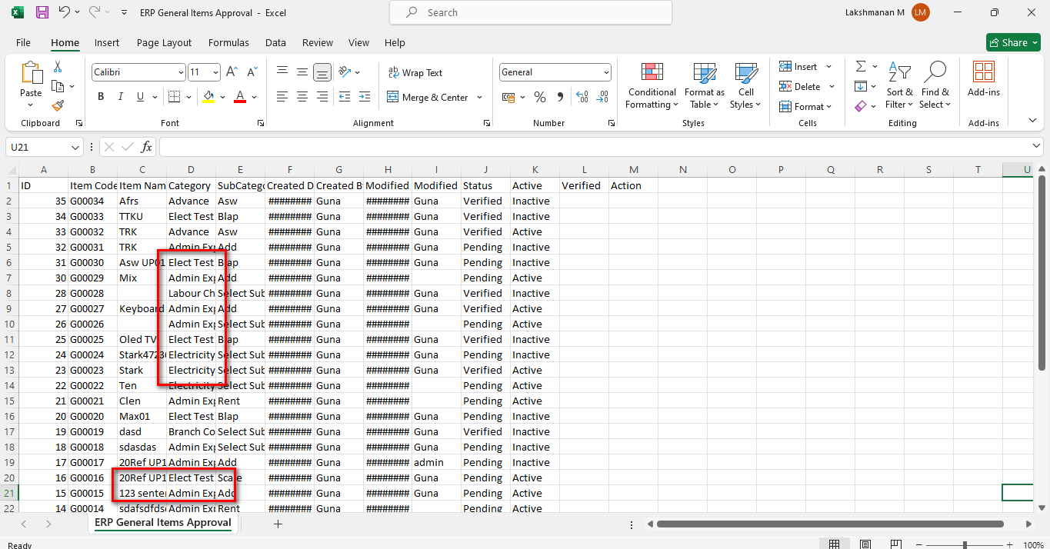 //

41. Unwanted column display in Finance General Item List Verification CSV/Excel file 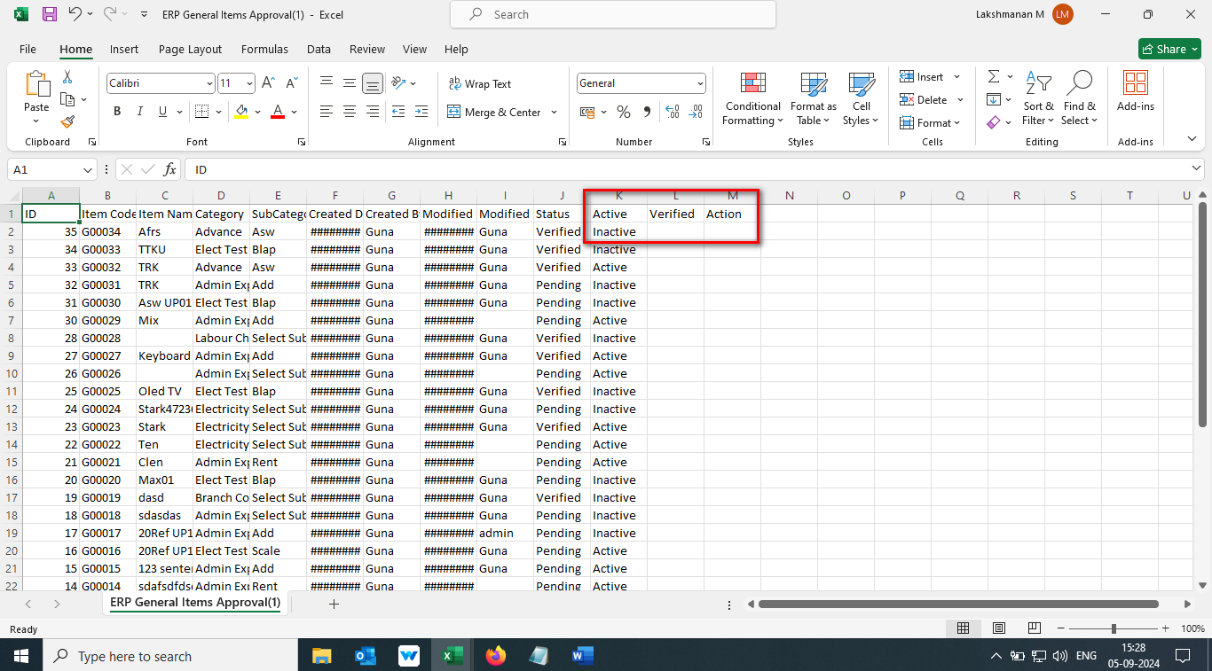

//

42. Sheet name display with number in Finance General Item List Verification CSV file 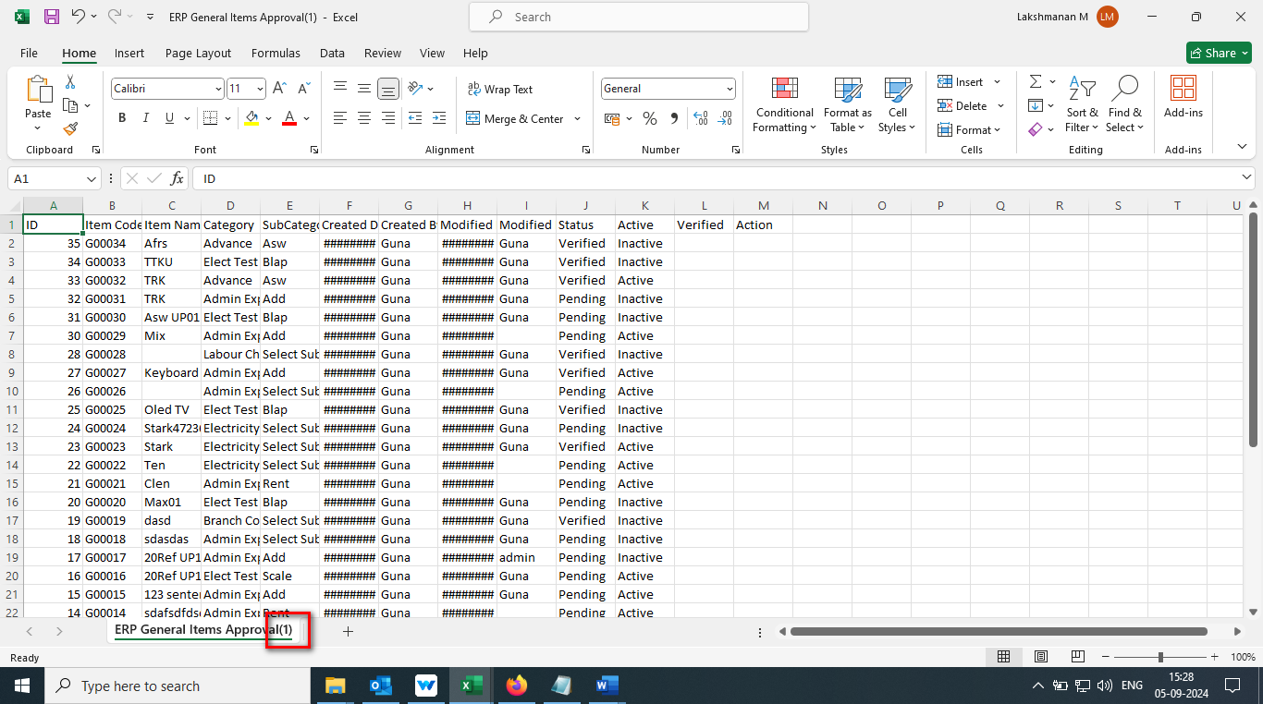

//

43. Mismatch sheet name display in Finance General Item List Verification Excel file 

